**Fitness Gym Membership, Trainer Scheduling, and Payment System with RFID Implementation**

A System Proposal presented to the

Faculty of the College of Computer and Information Sciences,

Polytechnic University of the Philippines, Sta. Mesa, Manila

In partial fulfillment for the course

INTE 4213 – Capstone Project

Cadena, John Homer A.

Casadores, Danielle Nicole J.

Doronila, John Carlo S.

Oreta, Vince Miguel D.

Pabustan, Rafhael B.

***Proponents***

**March, 2019**

**Table of Contents**

**1.1.** **Project Context** 7

**1.2.** **Technical Background** 8

1.2.1. Equipment/Hardware 8

1.2.2. Software 8

1.2.3. Peopleware/Manpower 8

1.2.4. Network Infrastructure/Architecture 8

1.2.5. Storage, Backup and Recovery Procedure 8

1.2.6. Security Procedures 8

**1.3.** **Problem Analysis** 9

1.3.1. Fishbone Diagram 9

1.3.2. Problem Analysis Diagram 9

1.3.3. Problem – Requirements Matrix 11

**1.4.** **Purpose and Description** 11

**1.5.** **Specific Objectives** 12

**1.6.** **Scope and Limitations** 12

**CHAPTER 3 – METHODOLOGIES** 15

**3.1.** **Requirements Analysis** 17

3.1.1. Requirements – Features Matrix 17

3.1.2 Context Diagram 18

3.1.3 System Boundaries 20

3.1.4 Use Case Diagram 21

3.1.5 Use Case Report 25

**3.2** **Design Specifications** 29

3.2.1. Activity Diagram 29

3.2.2. GUI Design 32

3.2.3. Entity Relationship Diagram 33

**References** 34

**Chapter 1 – Introduction**

* 1. **Project Context**

Most fitness gyms in our country still use logbooks and physical records to keep track with the management of their members. With such methods, they are prone to human errors which can threaten a business. The system that the group catered is the A-Team Fitness Center, located in Newton Plaza, Sta. Mesa, Manila, and the owner of the said gym is Mr. Carlo Luis Cheng.

It is a small, compact gym, but is well-equipped and has an almost-complete set of equipment to enhance one’s body. Since it is strategically placed in the square, many people will utilize and go to the said gym. Its peak hours are at 6pm-8pm, since most of the clients are youthful, able-bodied, and/or students who just got dismissed by their night shift class which benefits the gym when it comes to profit.

Based on the group’s empirical observation, the employees consist of a cashier, a trainer, some maintenance personnel, and a manager. Employees inside the gym have logbooks, which are written in classic pen-and-paper for either walk-ins or member, and will keep track of when they started at the gym, and when they end their session. The membership form the manager provided for us is very straightforward, but is often ignored, most likely since that Mr. Cheng said that, when using a gym, it is not necessary to be complicated.

This leads to unsecure processes, and lousy implementation of their membership. He stated that he wanted to expand into other branches, and become one of the big fitness gyms, such as Gold’s Gym. With this stated, it is required for the A-Team Fitness Center to have a system to clean their processes in which both the gym itself and the owner benefit to their own accord.

* 1. **Technical Background**
     1. Equipment/Hardware

They have a membership form which takes in form of a card, but some “minor” details can be discarded such as home address, city, age, etc. and is not prioritized very well. The fitness gym doesn’t have any equipment to use in terms of contacts and transactions. All of the transactions are done through their personal computers at home or at an internet café; these transactions will be recorded in a logbook.

* + 1. Software

All of the contact and messaging procedures are done through Facebook, or even text messaging; take note that this includes the membership application. Currently, they are not using any software in monitoring payments of fees, they have cashiers/receptionists to collect their payment.

1.2.3. Peopleware/Manpower

The fitness gym has a cashier that handles all of the payments, records transactions, and handles the membership applicants who walk in. The owner that handles membership applicants that contacts him through his social media accounts.

1.2.4. Network Infrastructure/Architecture

The current gym does not have any peripherals. They work purely manually. Therefore, they have no computers, and don’t have any network infrastructure or architecture. Most likely, the owner has access only to their Facebook page.

1.2.5. Storage, Backup, and Recovery Procedure

The business currently doesn’t have a reliable storage and recovery procedure as they only record transactions via logbooks. They have no backup, or any recovery aside from saved messages from either email or from the Facebook chat system.

1.2.6. Security Procedures

All the information is being secured only by the log book they use in the gym, meaning that the gym has a risky method of storing information.

* 1. **Problem Analysis**
     1. Fishbone Diagram



* + 1. Problem Analysis Diagram

The narrative report of the problem analysis diagram states that, three out of four factors in the fishbone have problems, namely:

* Methods – there are no tangible proof that the payments were transacted, and sometimes, the payment of some customers are left unattended. There are two trainers in the gym, and they do not have a systematic approach, and they schedule customers spontaneously. The classes and events are also not prioritized. Some payments are overlooked since some of the transactions are spoken. Leaving the customer unattended, thus having a reactive scheduling. Sometimes, the admin assigns a trainer a member without the trainer’s consent.
* Materials – They only use logbooks as the source of proof. Since they have no virtual record of the file, the security of the gym is unprotected. And the material for their promotion is social media via Facebook. Meaning that all of the messaging, membership, and appointments are not written on email, but on chat.
* Manpower – Limited staff leads to easier management, yet not very efficient. As the peak hours come, few employees cannot handle and monitor people who have each of their own, sudden break of the equipment, and other shortcomings that they have not predicted yet. The limited staff are cross-functional, in a way that makes the process unorganized and in flux.

The proponents analyzed the business process and found out that there is no proper monitoring system for payment of membership fees which can lead to loss of profit, no virtual recording of payment for referral purposes, and the process is small for a business that targets multiple branches. And the business also struggles with the assignment of their trainers to the members because their availability is not considered beforehand, therefore it is also hard for members to request for trainers.

Another problem is that they do not have back up for their records and all of it is recorded in just one logbook, this includes the membership application and payment of fees. They are unorganized at handling transactions and do not prioritize proof of payments such as invoices because they are contented with direct payment with no receipts issued.

A system that will handle both membership applications and membership fee monitoring, also will handle the trainer requests and trainer assignment that considers the availability of both parties involved, and a billing and payment system that will help the business to keep track of transactions that will improve the gym’s overall service.

* + 1. Problem – Requirements Matrix

|  |  |
| --- | --- |
| **Problem** | **Requirement** |
| Spoken membership application | Functionality that handles the applications in a systematic manner. |
| Unmonitored payment of membership fees | Functionality that would monitor and store the details of the payment of the customer |
| Loss of customer’s records due to lack of proper storage of records | Proper database schema that would store the records about the customer and can be retrieved anytime in any branch. |
| Unorganized assignment of personal trainers (“Kalabit system”) | A functionality that assign the trainers to customer that requests personal trainers and clear the availability of both parties. |
| The days are still counted when a customer is on a leave. | A functionality where the account will freeze or transfer to another individual when a notice is on the way |
| No health record system | A functionality where the client can input their health status as the trainer views it to determine the appropriate session for the client |
| “1-2-3 Modus” – When a client does not pay the gym and their services on time or not at all | Implement a suspension/banning function, and attendance monitoring to the system. |

* 1. **Purpose and Description**

The problems stated above can be diminished by a web application, specifically, Fitness Gym Membership, Billing, and Trainer Scheduling with Payment System to acquire a solution. The purpose of the system is to ease the workflow of the A-Team Fitness Center and to help the owner benefit from the system so that he will not resort to such manual processing. The system of the current process is as basic and simple as the other gyms, and this gym aspires to be one of the best gyms like Gold’s Gym or Anytime Fitness, therefore implementing a bigger, automated system helps them to familiarize more about branching. The system aims to make the process of the gym bigger, yet manageable, clean, and easy to understand.

* 1. **Specific Objectives**
* To create an admin view, trainer view, and a client view for easy usage and availability purposes.
* To monitor the memberships that will expire, trainer assignment, the payment record, and people affiliated with either classes/events.
* To provide accurate data at presentation in compliance for the clients and admins that will utilize the system.
* To lessen paperwork, and other redundant processes.
* To make the scheduling effective and well distributed among classes, events, and trainer-client sessions.
* To create a clean business flow that is understandable, and resistant to flaws.
* To secure and store transactions from overlooked payments, and spoken agreements.
* To have a virtual storage that will keep the records intact even though the physical records are gone.
  1. **Scope and Limitations**

The system’s main flow generally engages on the gym’s membership, including its discounts and promos. Moreover, the system will also handle the appointment of members to personal trainers if they wish to have one and gives a platform for scheduling the training process. Progress will also be recorded. Group classes will be managed and members that are currently applied at the class are handled. The billing and payment, trainer assignment, events/class management and scheduling, and membership application are the overall scope of the system.

“Walk-ins” or people who enter a gym and pay only for the day will not be managed, but the income from them will also be recorded in the system. The system’s scope is only stated above. Anything unrelated to the system is considered out of bounds to the proponent’s scope. Criticisms and revisions are tolerated.

**1.7. DATA AND PROCESS**

The diagrams that will be stated below describe the core business rules implemented in A-Team Fitness Center.

* + 1. 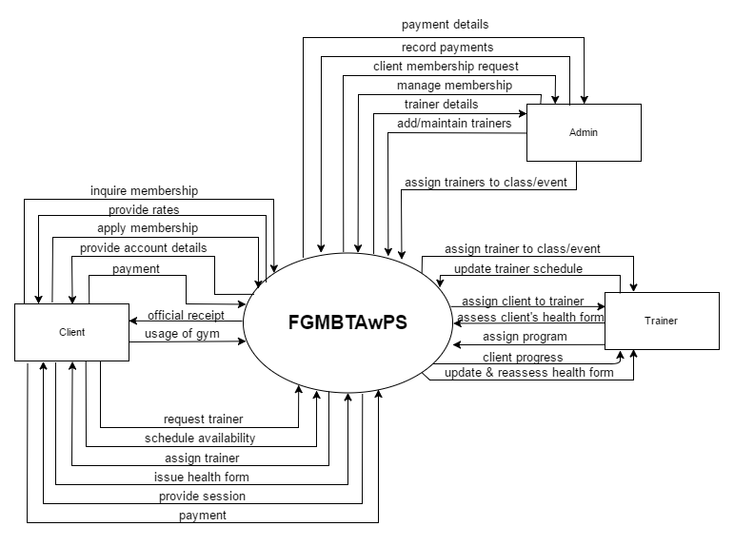Context Diagram

Gym Process

* + 1. Data Flow Diagram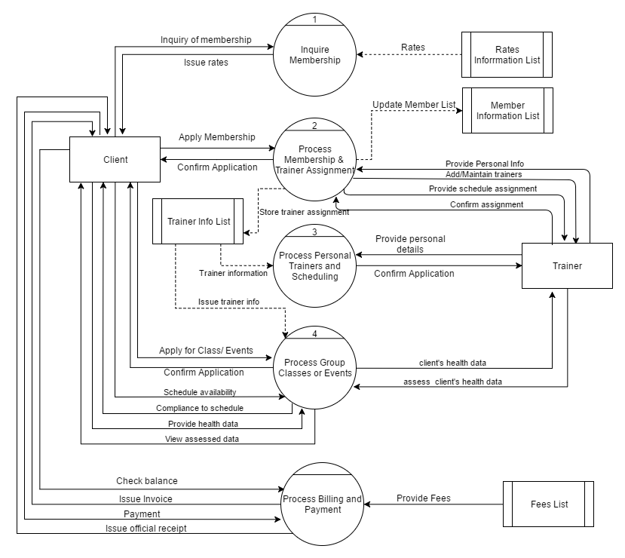

**Chapter 3 – Methodology**

* 1. **Requirements Analysis**
     1. Requirements – Features Matrix

|  |  |  |  |  |  |  |  |  |  |
| --- | --- | --- | --- | --- | --- | --- | --- | --- | --- |
|  |  |  |  |  |  |  |  |  |  |
| User Log-in | ✔ |  | ✔ |  |  |  |  |  | ✔ |
| Membership Registration | ✔ | ✔ | ✔ |  |  |  |  |  | ✔ |
| Membership Freezing |  | ✔ | ✔ |  |  |  |  |  | ✔ |
| Trainer Scheduling |  | ✔ | ✔ |  |  |  |  |  | ✔ |
| Fees Management |  |  | ✔ |  |  |  |  |  | ✔ |
| Class/Session  Enrollment |  | ✔ | ✔ |  |  |  |  |  |  |
| Event Management |  | ✔ | ✔ |  |  |  |  |  |  |
| Notifications |  |  | ✔ |  |  |  |  |  | ✔ |
| Billing | ✔ | ✔ | ✔ |  |  |  |  |  | ✔ |
| Payment | ✔ | ✔ | ✔ |  |  |  |  |  | ✔ |

The feature matrix that the group decided will be based on the following criteria: data security, automated transactions, ease in workflow, and solves the problems. Some of the features in the feature matrix were added, due to the stakeholders’ request for the proponents to comply.

* + 1. 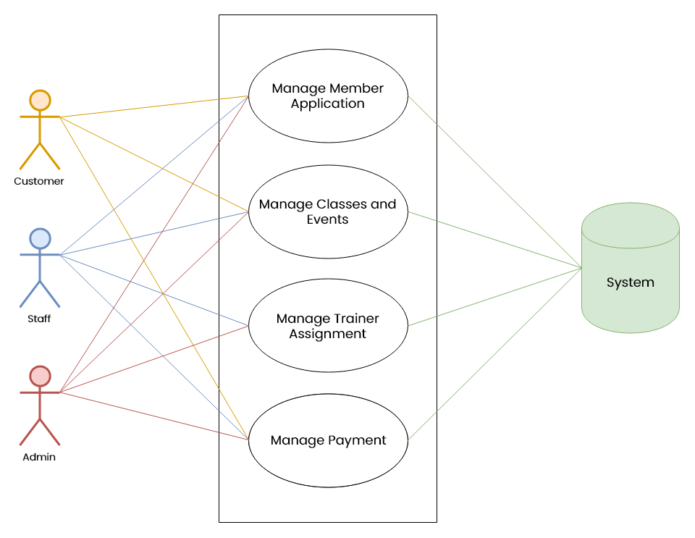System Boundaries

The customer (soon to be a member) and staff will generally handle the member application. After the application, the customer will receive a code from their email to surrender it at the staff. The staff then will verify if the generated code is correct and receive the payment from the customer. If so, the customer will become a member and will receive membership benefits, else the customer must apply again. For the admin, it is required for them to access every module of the system. The staff will then manage classes and events, where the member (former customer) can apply/enroll to. The trainer will then accommodate the member by complying to the trainer’s assignment.

* + 1. Use Case Diagram

**Use Case: Membership Application**

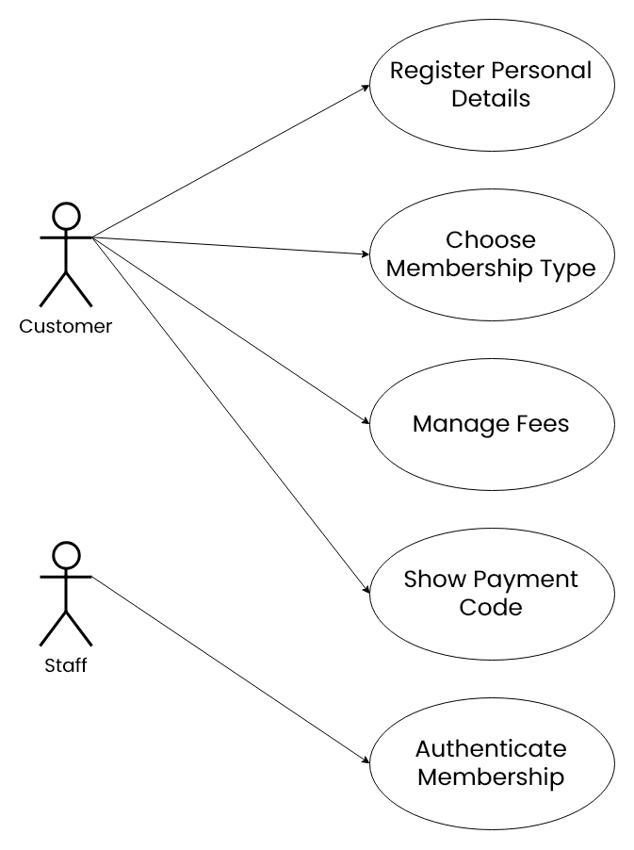

The customer will register from the web. The customer can access the registration physically, but from the staff’s portal. In the web, the customer will fill the necessary credentials and submit it. After the submission, the customer will pay the fee, along with the payment code received through email. The customer the shows the code to the staff for verification purposes, and if the code is correct, the customer will be granted as a member.

**Use Case: Manage Classes/Sessions**

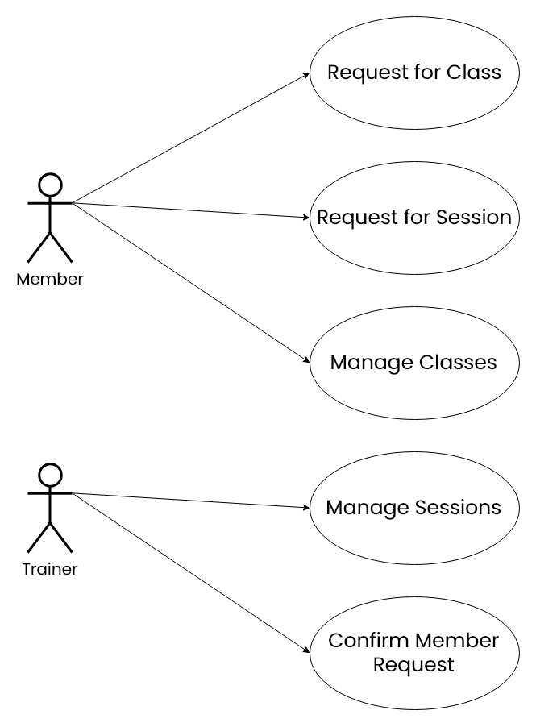

The member can request either for classes and sessions. The member cannot request for an event since this was generated by the staff, that means, the member can only attend at the event. The trainer will then manage the sessions personally. Then the trainer will confirm the member request.

**Use Case: Trainer Assignment**

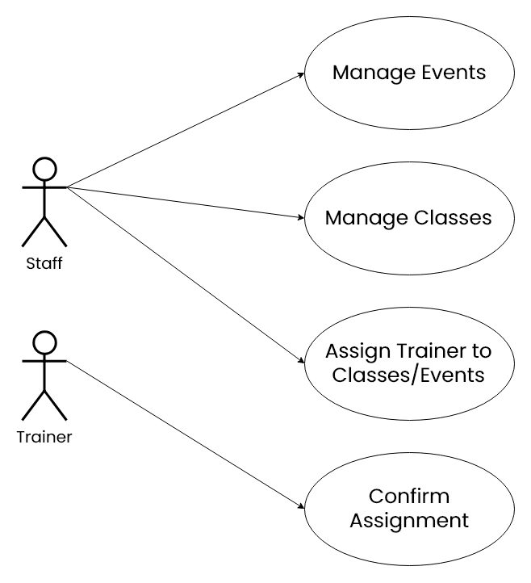

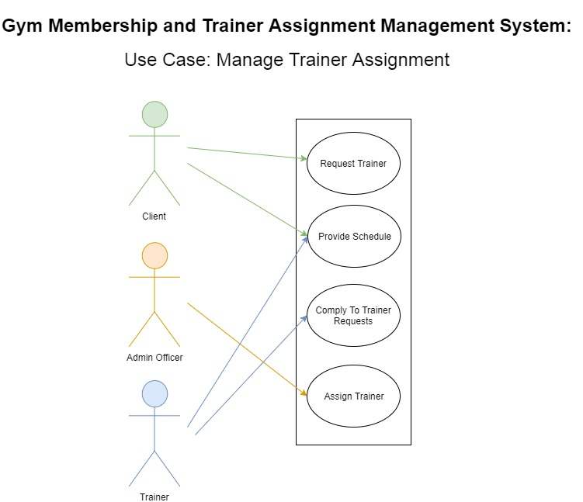

The staff earlier will manage events, classes, but sessions are their personal business. The staff will now assign to the trainer on what to do by sending them a notification. The trainer can accept or reject the assignment given from the staff.

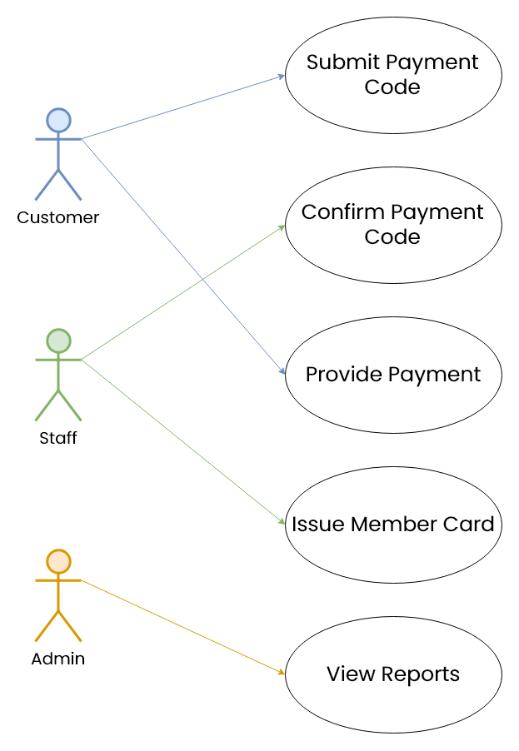**Use Case: Payment**

The payment code earlier generated by the system will be viewed in the staff’s portal, and let them confirm. The staff will receive the payment and record it in the system, while they issue the customer a member card. The admin can view the reports if the transaction is made.

* + 1. Use Case Report

|  |  |
| --- | --- |
| **Use Case Name** | Membership Application |
| Actors | Customer, Staff |
| Purpose | This use case describes how the client will avail membership and the authentication process of the membership. |
| Brief Description | Granting memberships. |
| Pre-Condition/s | Customer has access to the portal. |
| Post-Condition/s | Customer will become a member. |

|  |  |
| --- | --- |
| **Basic Flow** | |
| **Actor Action** | **System Response** |
| 1. Member fills and submits membership form. | A register form will show up for the customer to fill. |
| 1. Customer finishes filling up the registration. | The system will prompt to head to their email for the payment code. |
| 1. Customer hands the code to the staff. | The system displays the pending members, along with its auto-generated code. |
| 1. Staff authenticates the code. | The system will record the member and is now verified in the system. |

|  |  |
| --- | --- |
| **Use Case Name** | Manage Classes/Sessions |
| Actors | Member, Trainer |
| Purpose | This use case shows the member’s application to the sessions and classes from the gym to which the trainer complies to do with regards to their schedule. |
| Brief Description | Class and session application. |
| Pre-Condition/s | Customer is already a member. |
| Post-Condition/s | The member is enrolled to classes and sessions  The trainer accommodates the members along with its applied requests. |

|  |  |
| --- | --- |
| **Basic Flow** | |
| **Actor Action** | **System Response** |
| 1. The member looks for classes and sessions. | The system will direct the member to the view that they wanted. |
| 1. The member will view the selected classes/sessions. | The system will display a modal where the member can see what the content of their selected class. |
| 1. The member will apply at the classes/sessions. | The system will prompt a validation whether or not the member is sure. If sure, the system will send a notification to the trainer. |
| 1. The trainer views the applicants of their classes/sessions. | The system will display every single member applied to their course. |
| 1. The trainer accepts/rejects requests. | The system will prompt a validation whether to accept/reject the pending member. If accept, the system will insert the member to the class/session. |
| 1. Trainer will provide programs for the client. | The system will prompt the client to select the following packages of sessions to choose from, based on the health data the trainer accumulated. |
| 1. Client complies with the programs. | The system will set the client’s status on their selected package. |
| 1. Trainer updates client’s health status. | The system will track the changes, and keeps the record for the progress. |
| **Alternative Flow** | **System Response** |
| **Items #1& #3:** Sudden interruption for the admin from adding/maintaining trainers. | The process is voided. |
| **Items #2& #4:**Both client and trainer input incomplete credentials. | System will prompt to fill out missing required fields to continue. |
| **Item #5:** Trainer made a mistake in giving the wrong session. | System will grant the trainer to edit or delete the unnecessary package. |
| **Item #6:** Client did not complied with the program. | The system will prompt a reschedule for the client. If the reschedule is rejected or ignored, the session will still be count. |

|  |  |
| --- | --- |
| **Use Case Name** | Manage Group Classes or Events |
| Actors | Admin, Client, Trainer |
| Purpose | This use case shows the management of the group classes and events in the gym. |
| Brief Description | Creation of classes or events, assignment of staff-in-charge, class/event application, confirmation of the client’s application, and payment. |
| Pre-Condition/s | Admin will create a class/event, assign a trainer that is in charge to the class/event, and manage the payment.  Client will apply for a/an class/event.  Trainer will approve the application of the client. |
| Post-Condition/s | Admin successfully created a class/event.  Admin assigned a staff-in-charge, and managed the fees.  Client complied with the class/event. |

|  |  |
| --- | --- |
| **Basic Flow** | |
| **Actor Action** | **System Response** |
| 1. Admin creates class/event. | System issues a form for the admin to fill up to make the class/event. This will add a schedule exclusive to class/events. |
| 1. Admin will assign the staff-in-charge. | In the same form, there is a selection of trainers available to the class/event. Trainer’s schedule will be occupied when assigned. |
| 1. Client applies for class/events. | The system will let the client go to the view where classes and events are displayed, and can see its schedule. Once selected, the schedule be will occupied when applied. |
| 1. Trainer confirms client application for class/events. | The system will record the client’s attendance to the said class/events. When the classes/events expire, the schedule will be freed. |
| 1. Client pay fees. | The system will record the separate payment of the fees paid in the cashier. |
| **Alternative Flow** | **System Response** |
| **Item #1 & #2:** Admin gets interrupted via technical difficulties. | The process is voided. |
| **Item #2:** Trainer has a schedule conflict with a client. | The system will prompt the trainer to overwrite the schedule. If overwrite, the system will give the client a prompt that the trainer is occupied in a class/event and to choose a different trainer. If not overwrite, the system will prompt the admin that the trainer rejected his/her trainer assignment. |
| **Item #3:** Client has a schedule conflict. | The system will prompt the client to overwrite the schedule. If overwrite, the system overwrites the schedule, and reschedules the trainer at the different time. If not, the class/event offer will be voided. |
| Item #4: Trainer rejects client application for class. | The system will queue the client for the next class/event |

|  |  |
| --- | --- |
| **Use Case Name** | Manage Billing and Payment |
| Actors | Admin, Client |
| Purpose | This use case describes the management of billing and payment that is happening between the admin and client. |
| Brief Description | Provision and viewing of invoice, recording of payment, and issuance of official receipt. |
| Pre-Condition | Admin will provide invoice.  Client will issue payment.  Admin will update the payment record in the system.  Admin will issue the official receipt. |
| Post-Condition/s | Admin collected the payment and issued the official receipt.  Client has his/her own copy of the official receipt. |

|  |  |
| --- | --- |
| **Basic Flow** | |
| **Actor Action** | **System Response** |
| 1. Admin will provide the invoice. | The system will issue a pdf invoice that complies with the fees the client made. |
| 1. Client views the invoice. | The system will let the client view the bill. |
| 1. Client pays and admin records the payment. | The system will record the transaction in the admin view. |
| 1. Admin will issue official receipt. | The system will provide a .pdf version of the official receipt for the admin to sign virtually. |
| **Alternative Flow** | **System Response** |
| **Item #3:** The admin gets interrupted during the recording. | The process is voided. |

* 1. **Design Specifications**
     1. Activity Diagram

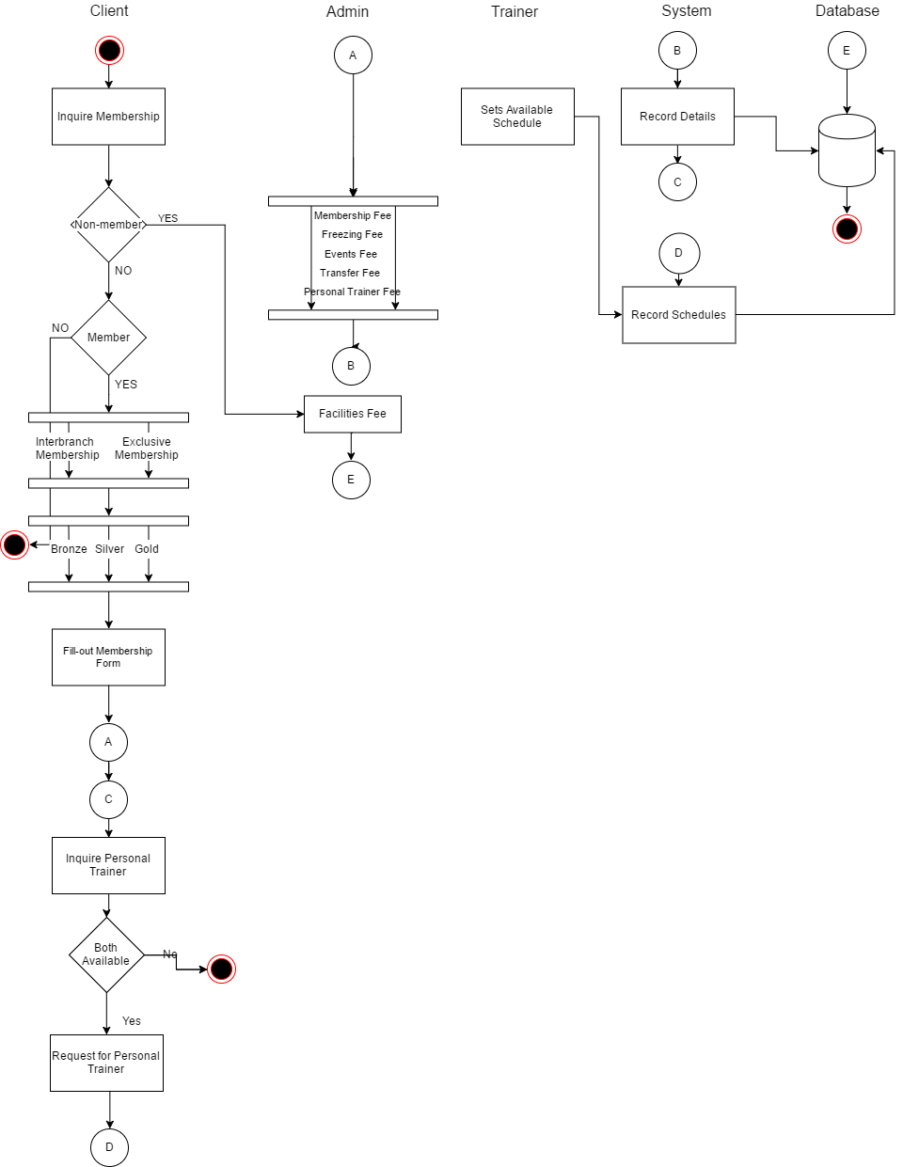**Activity Diagram:** Manage Client Application and Personal Trainer Assignment

**Activity Diagram:** Manage Personal Trainer and Scheduling

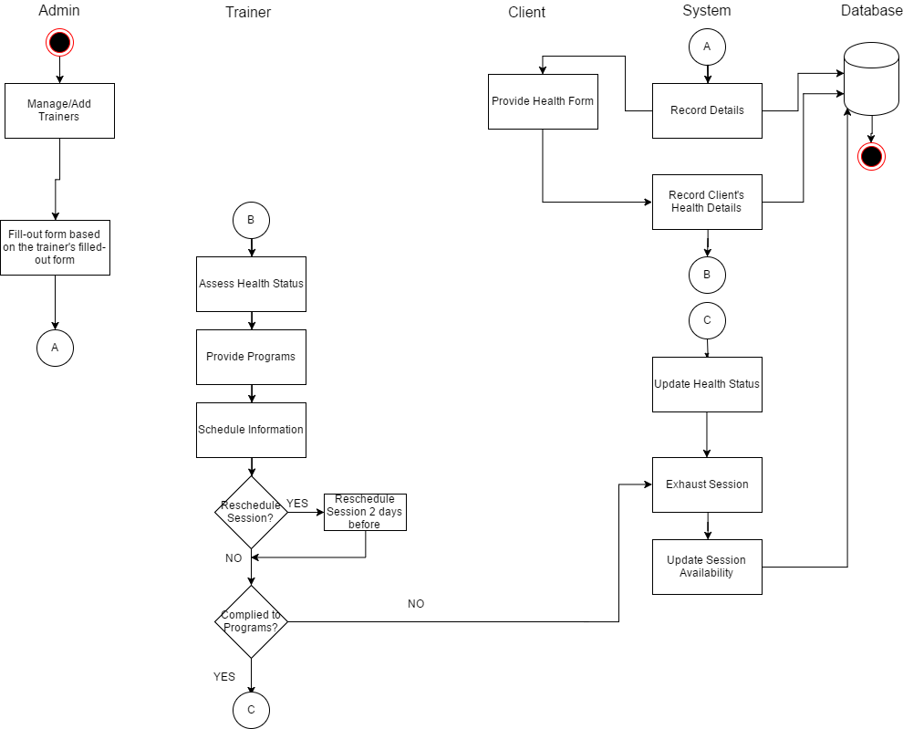

**Activity Diagram:** Manage Group Classes or Events

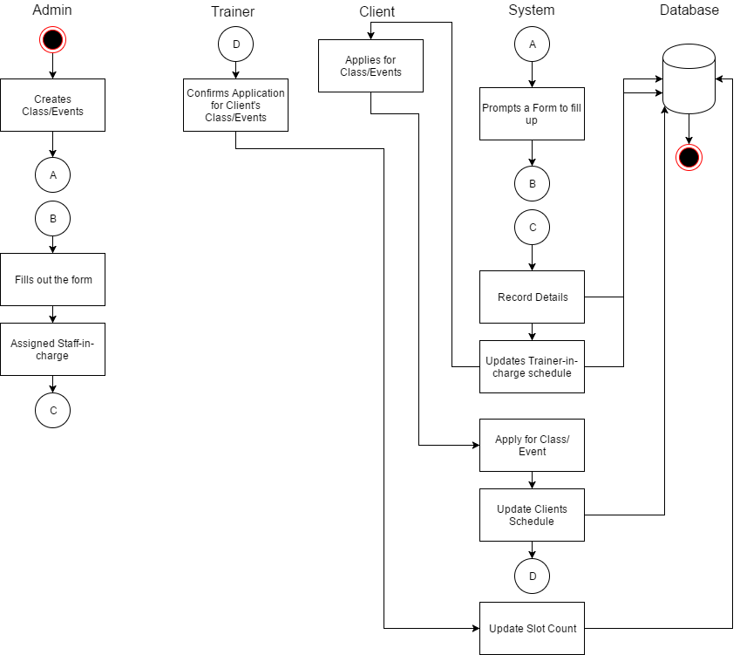

**Activity Diagram:** Manage Billing and Payment

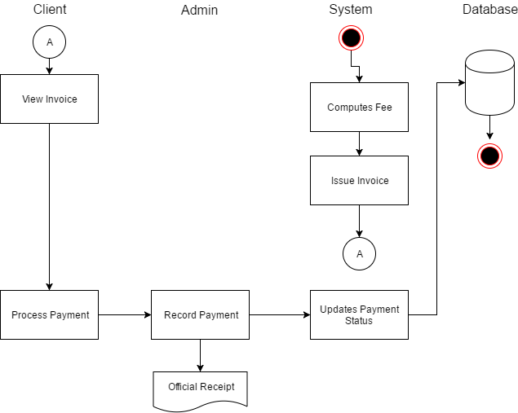

* + 1. GUI Design

Landing Page



Admin/Trainer Log-in

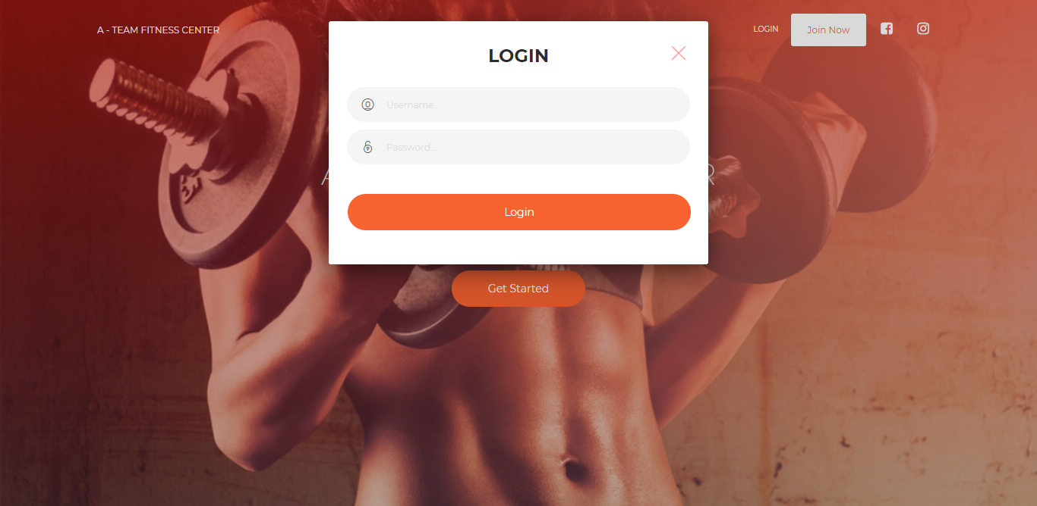

Admin View: Dashboard

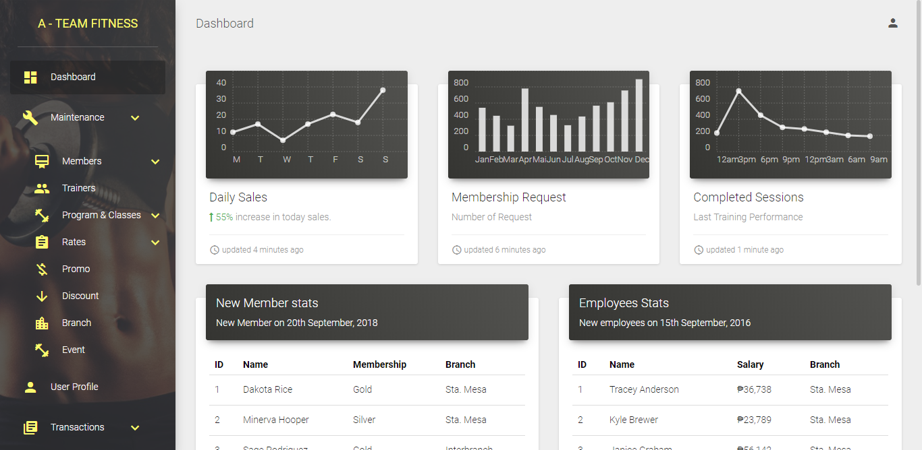

Admin View: Members

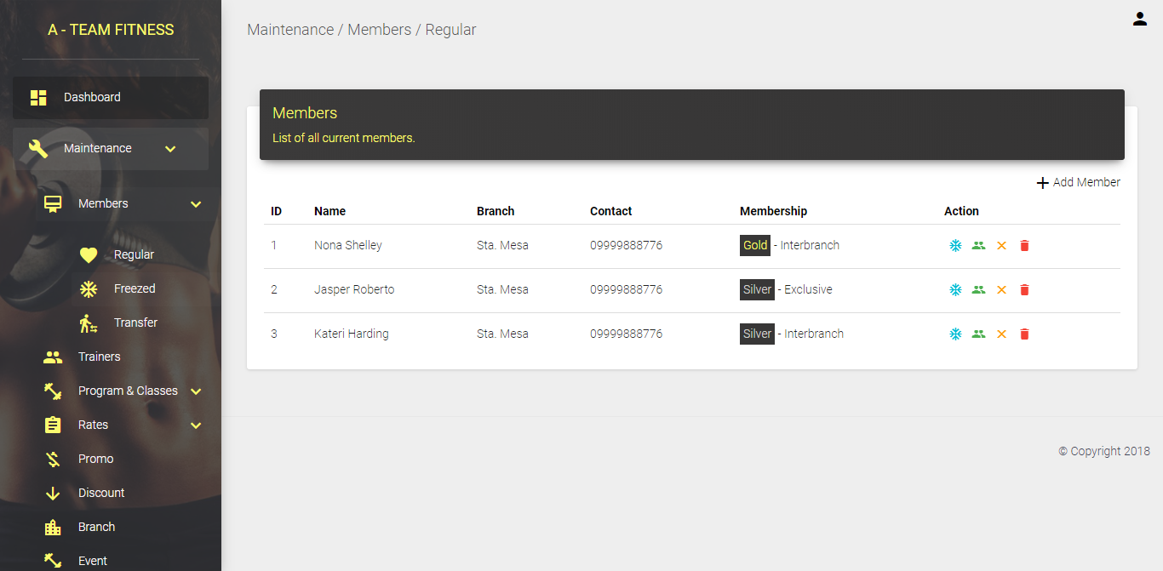

Admin View: Register Member

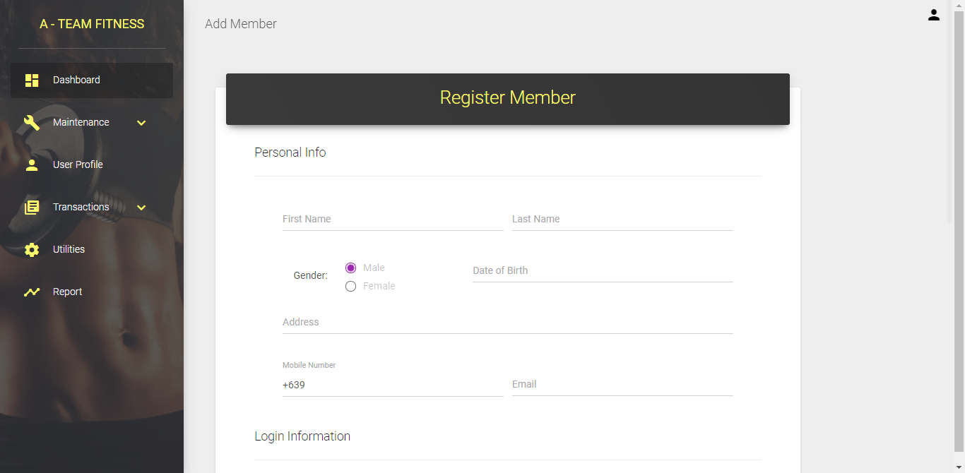

Admin View: CRUD Members

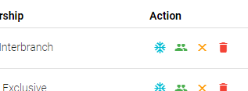

Admin View (Modal): Freeze Member Account

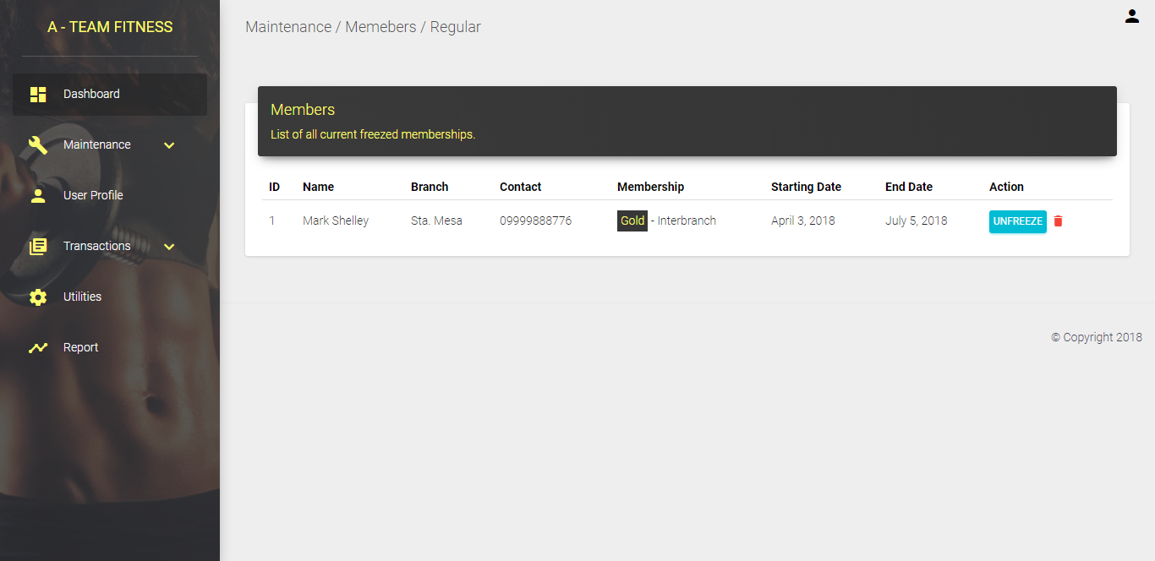

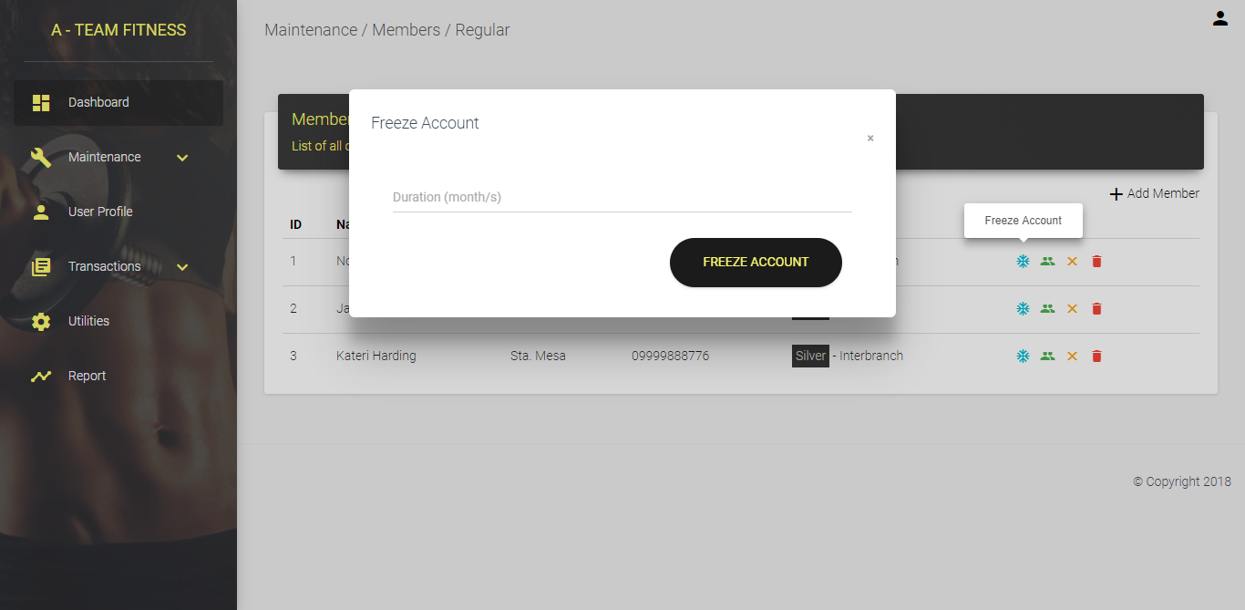

Admin View: Add Member (Existing)

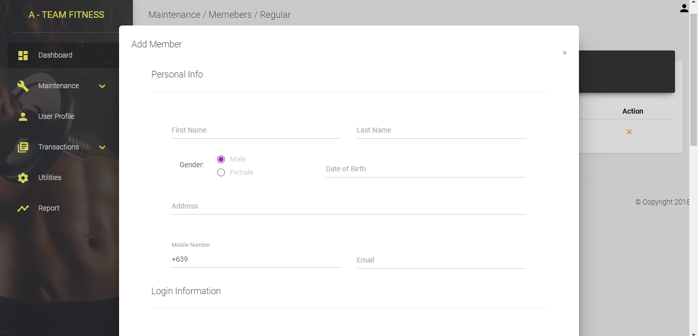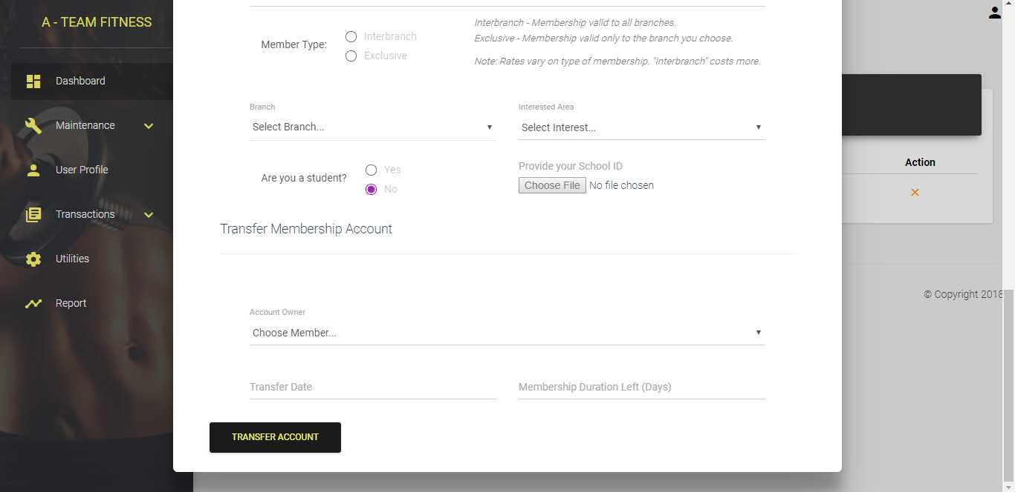

Member View: Sign-up Form

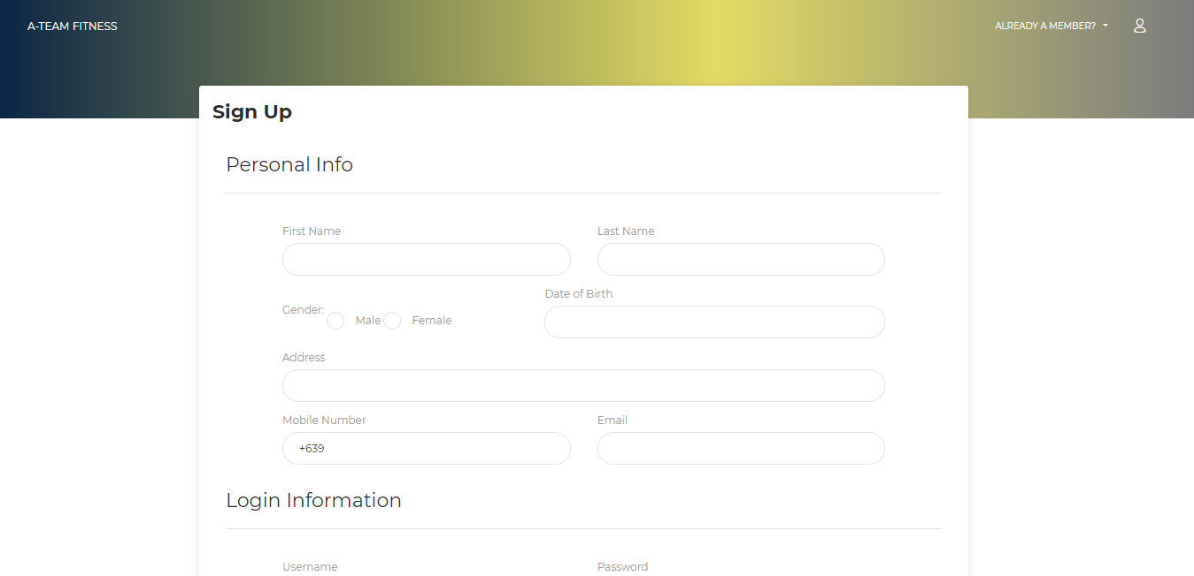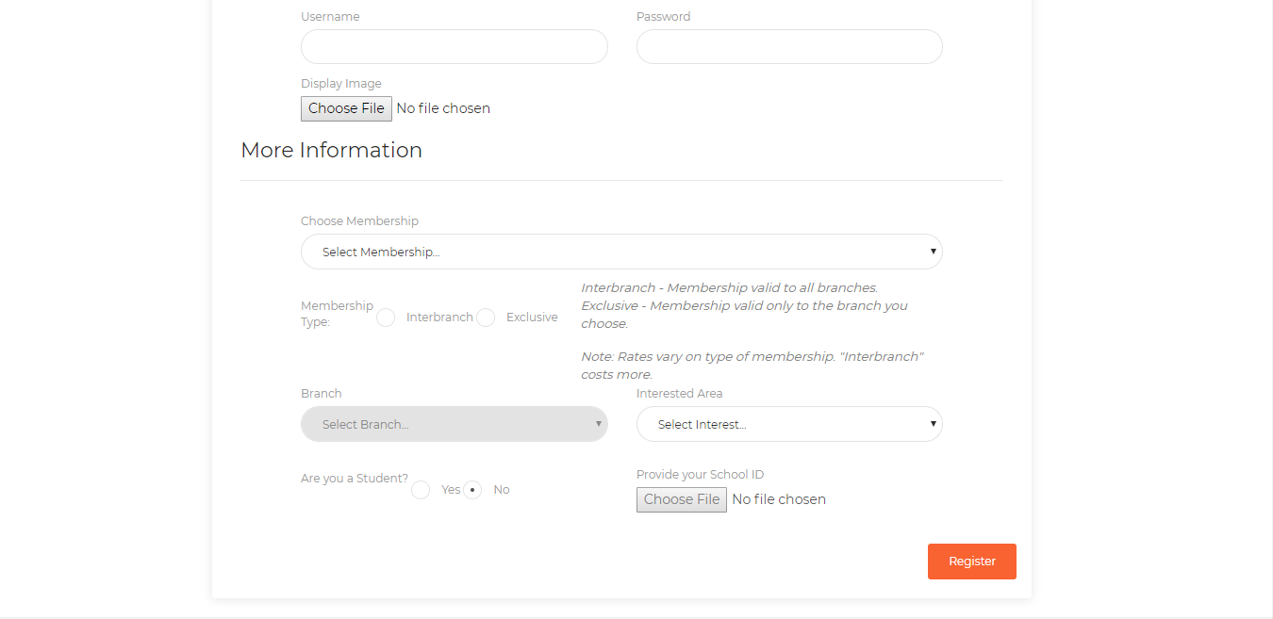

Admin View: Trainers

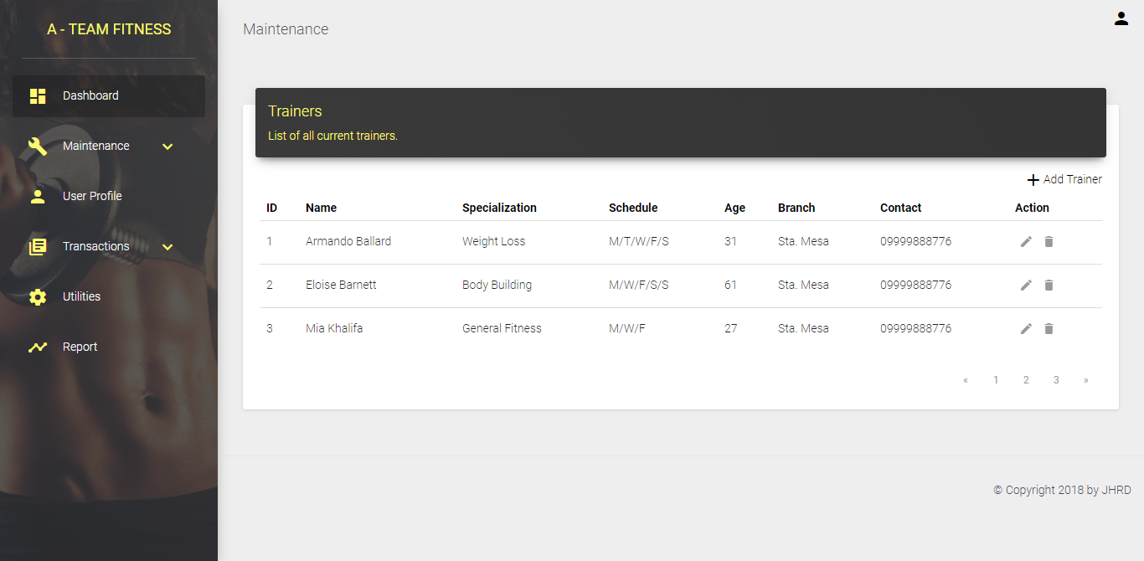

Admin View: Add Trainer

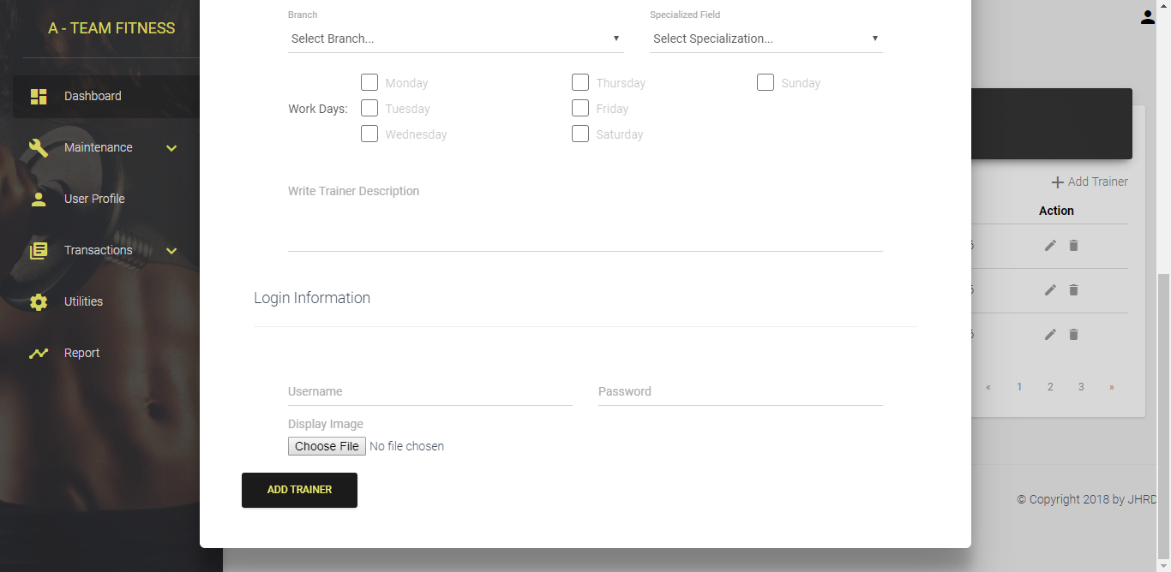

Admin View: PT Sessions

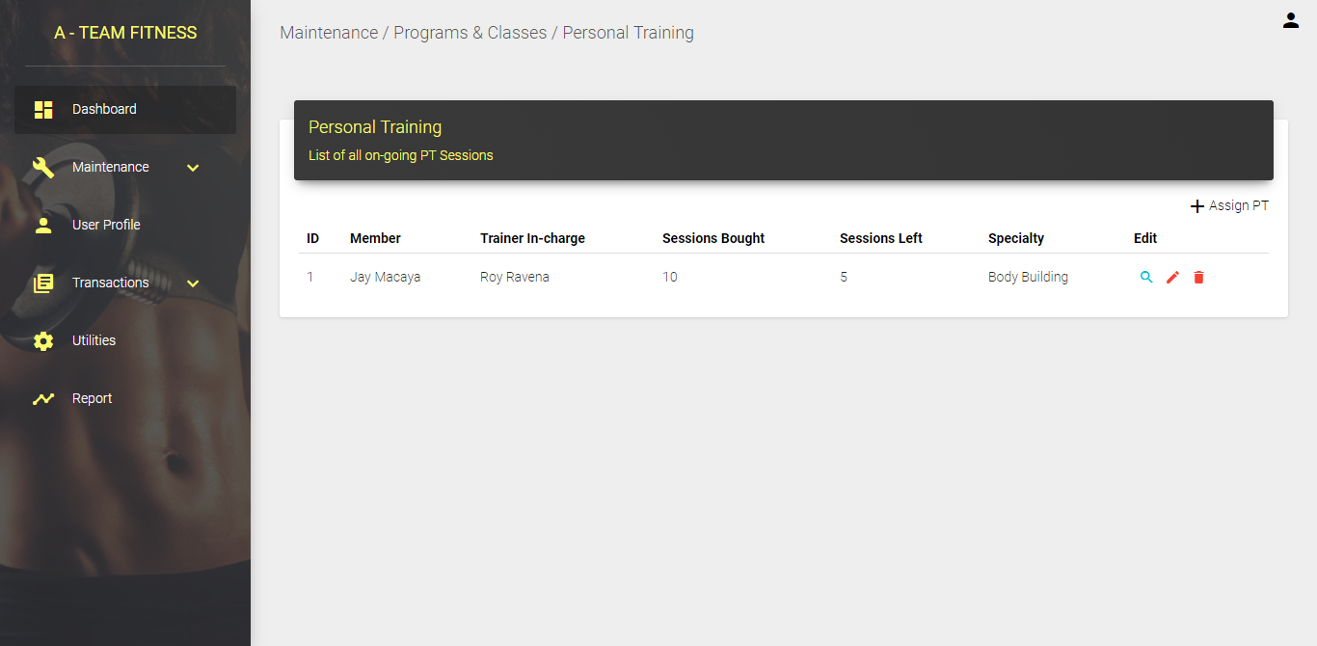

Admin View: PT Assignment

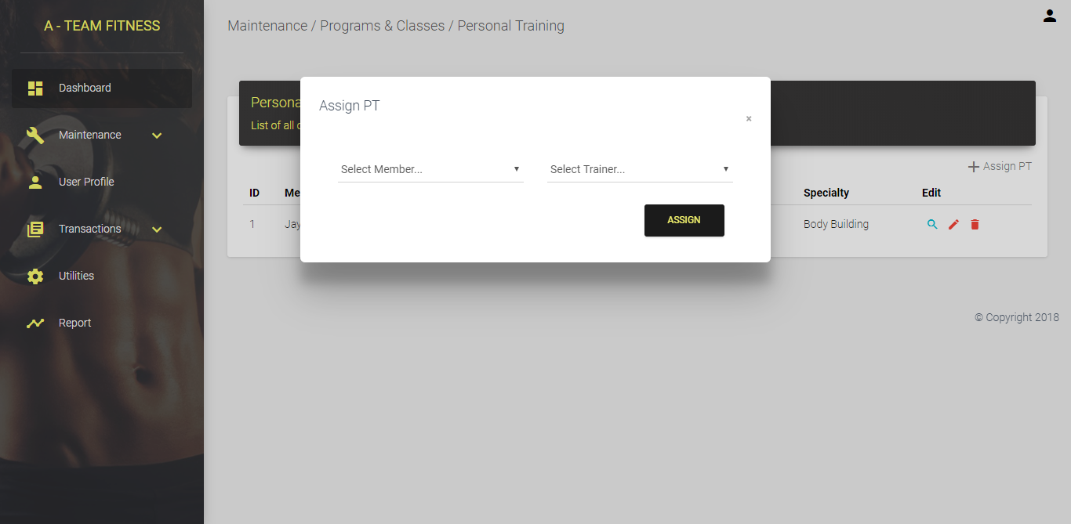

Admin View: Group Classes

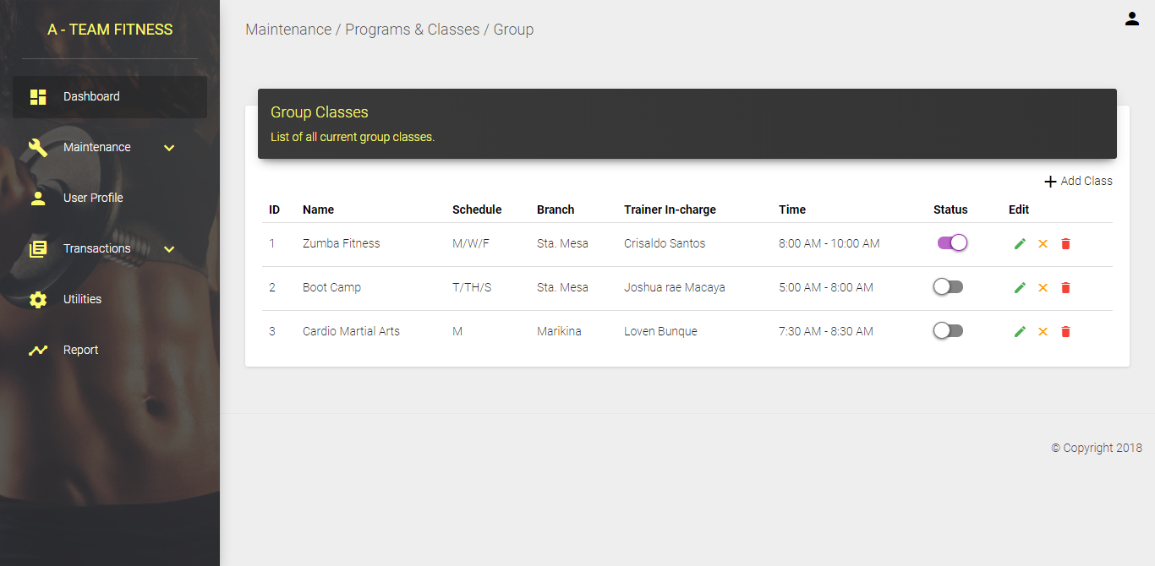

Admin View (Modal): Add Class

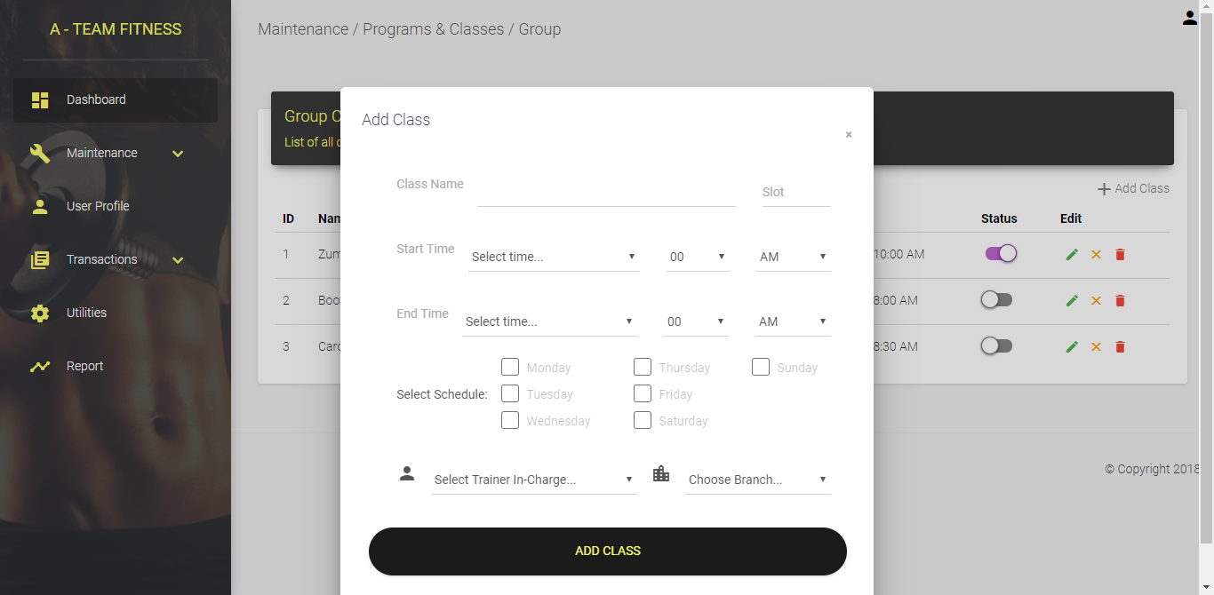

Admin View: Facility Rates and Fees

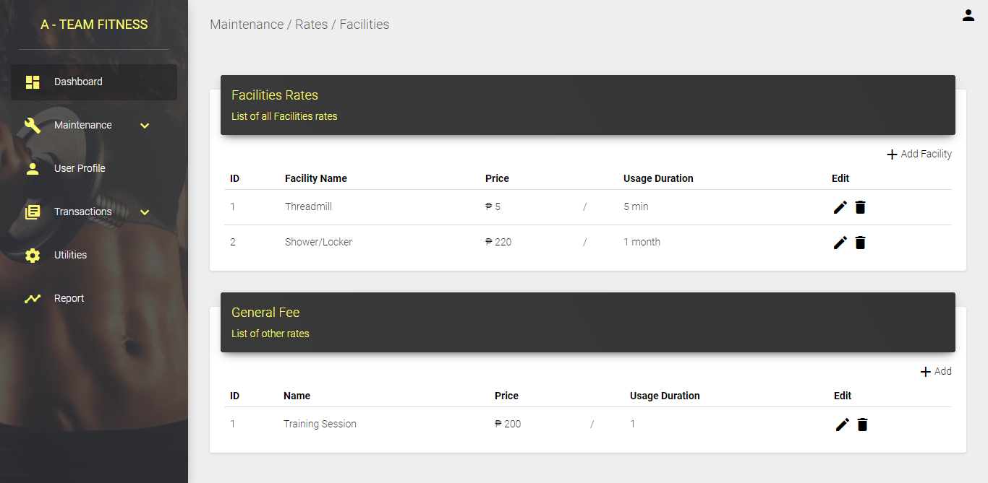

Admin View: Add Facility and Fees

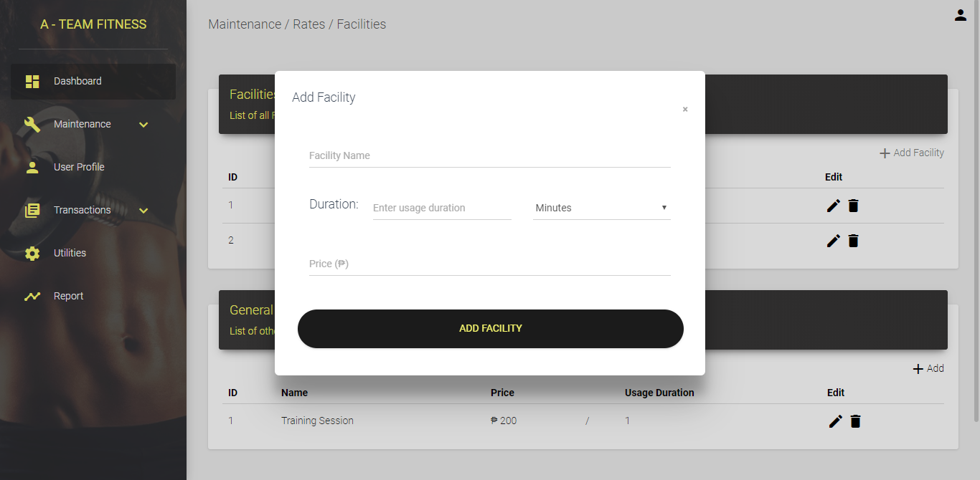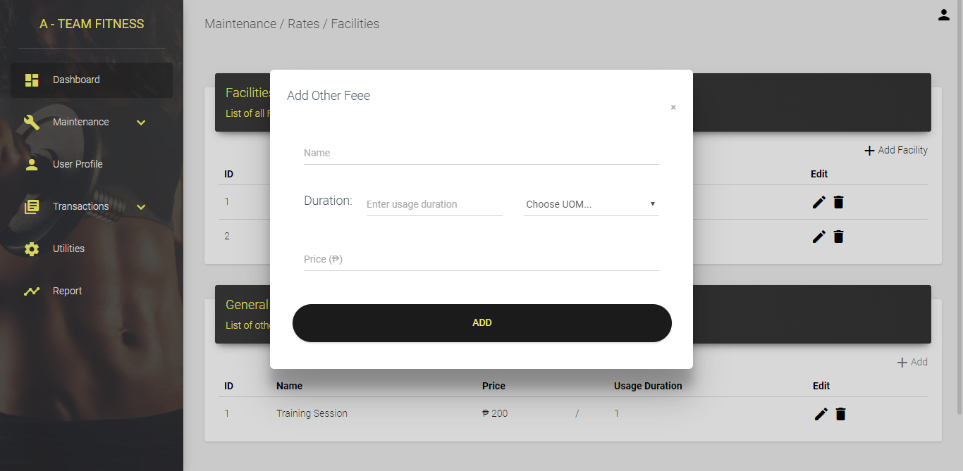

Admin View: Promos & Discounts

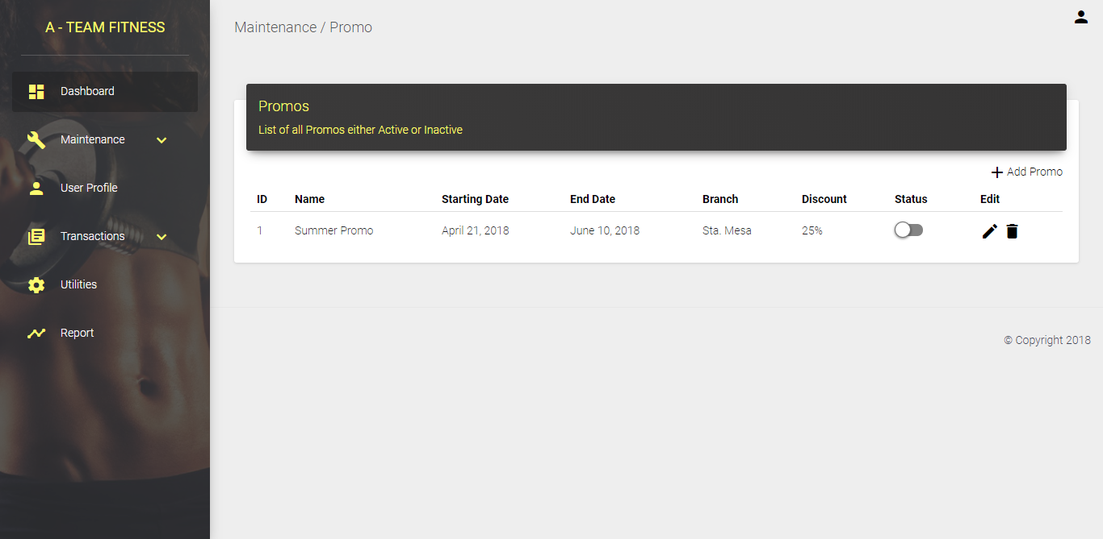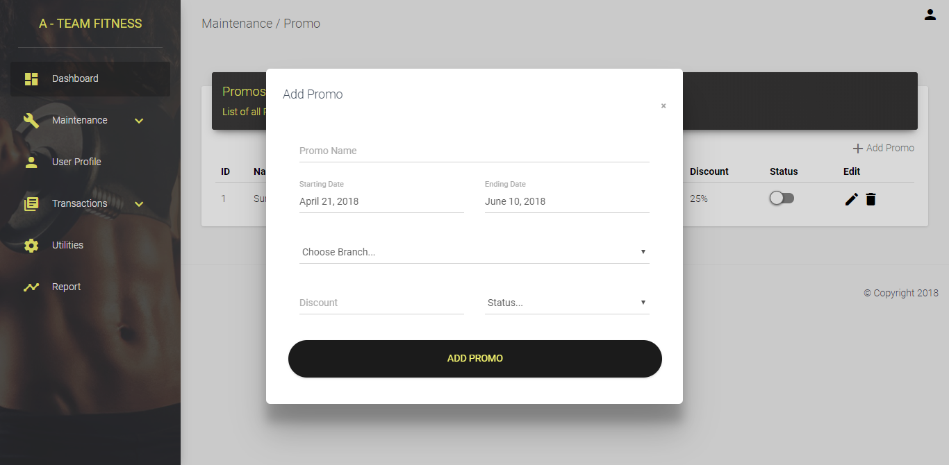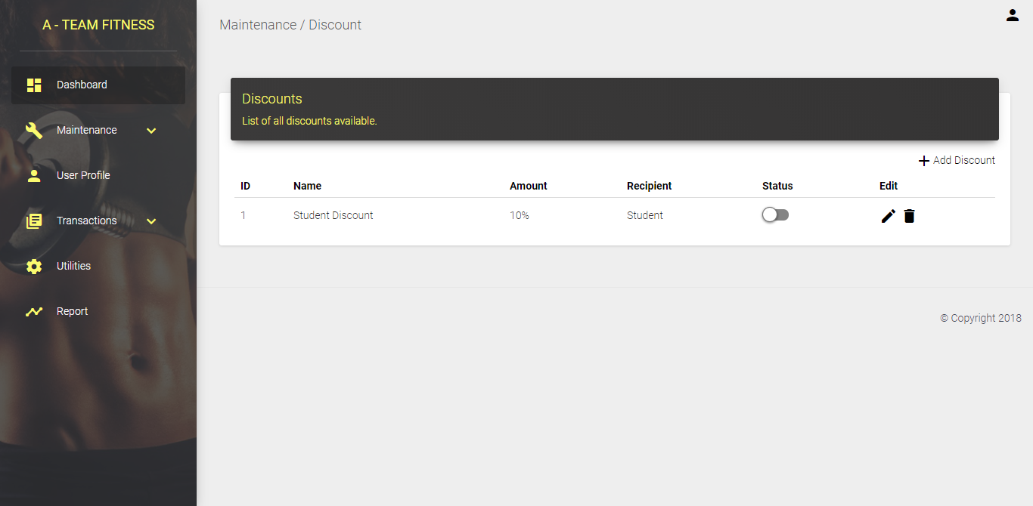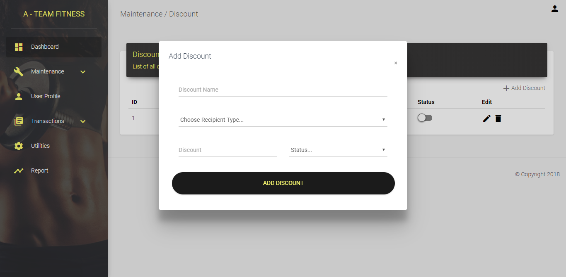

Admin View: Branch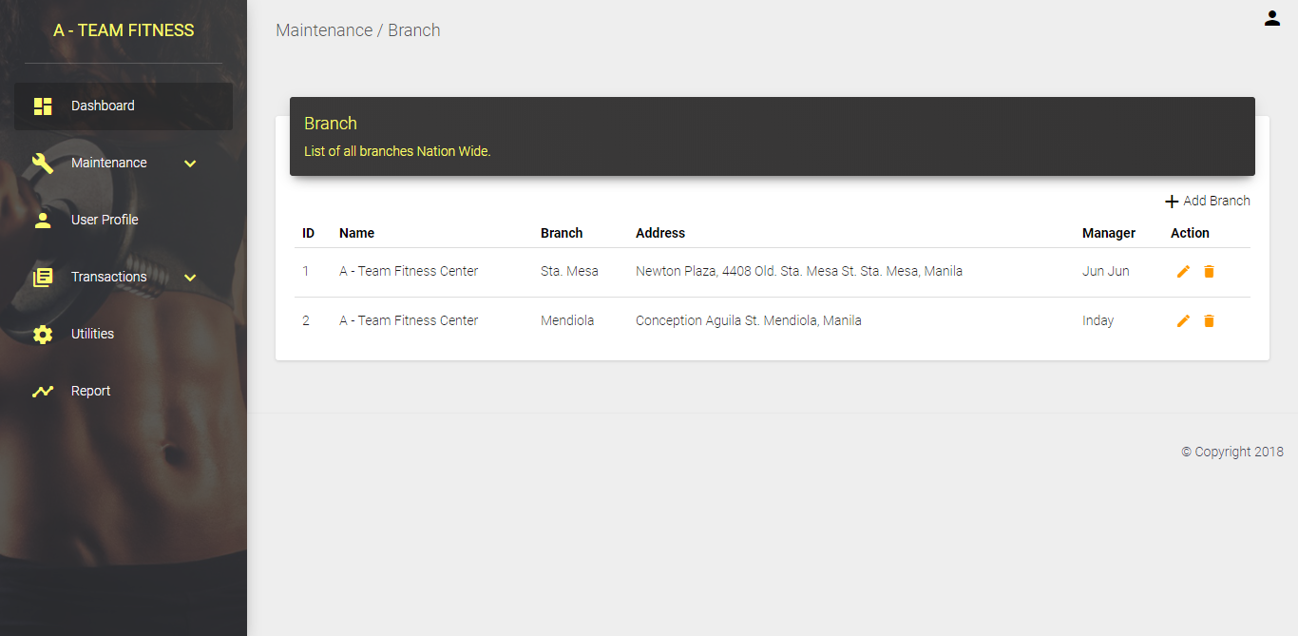

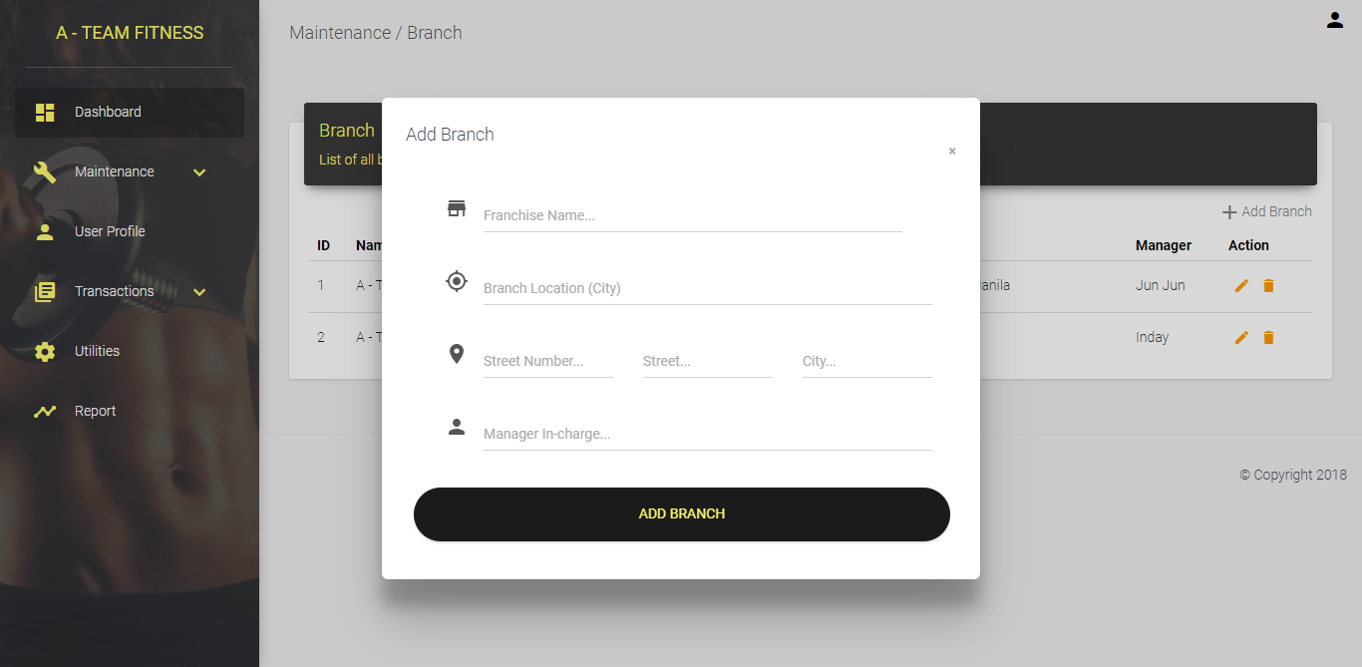

Admin View: Events

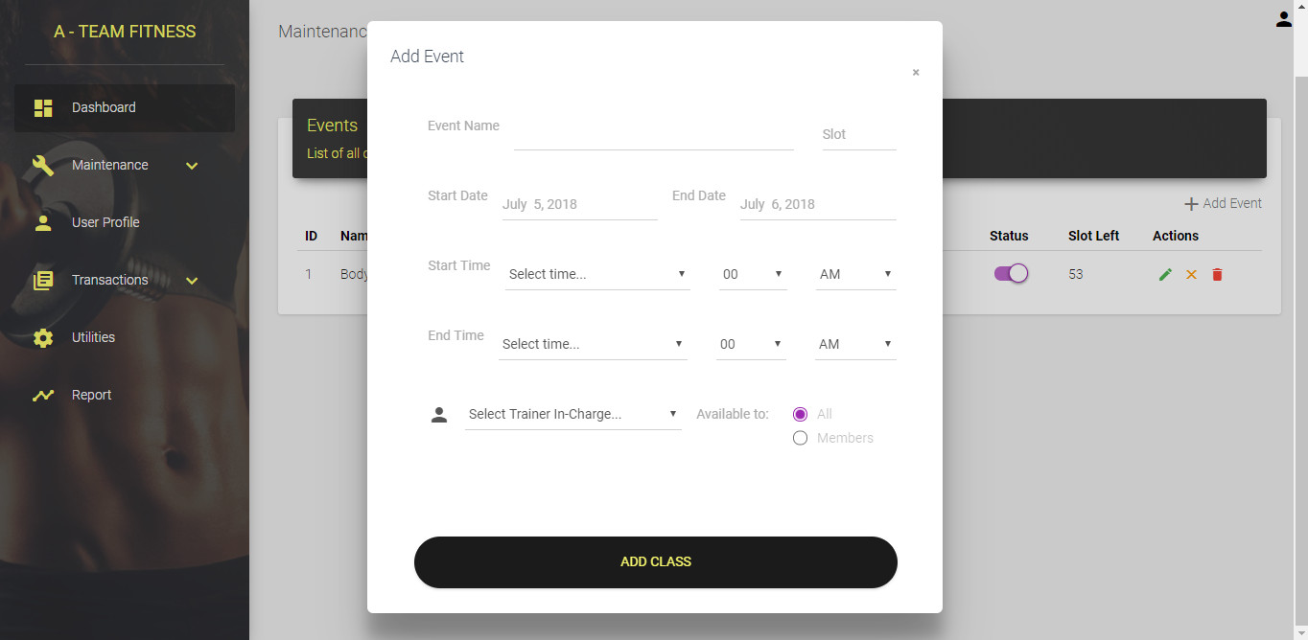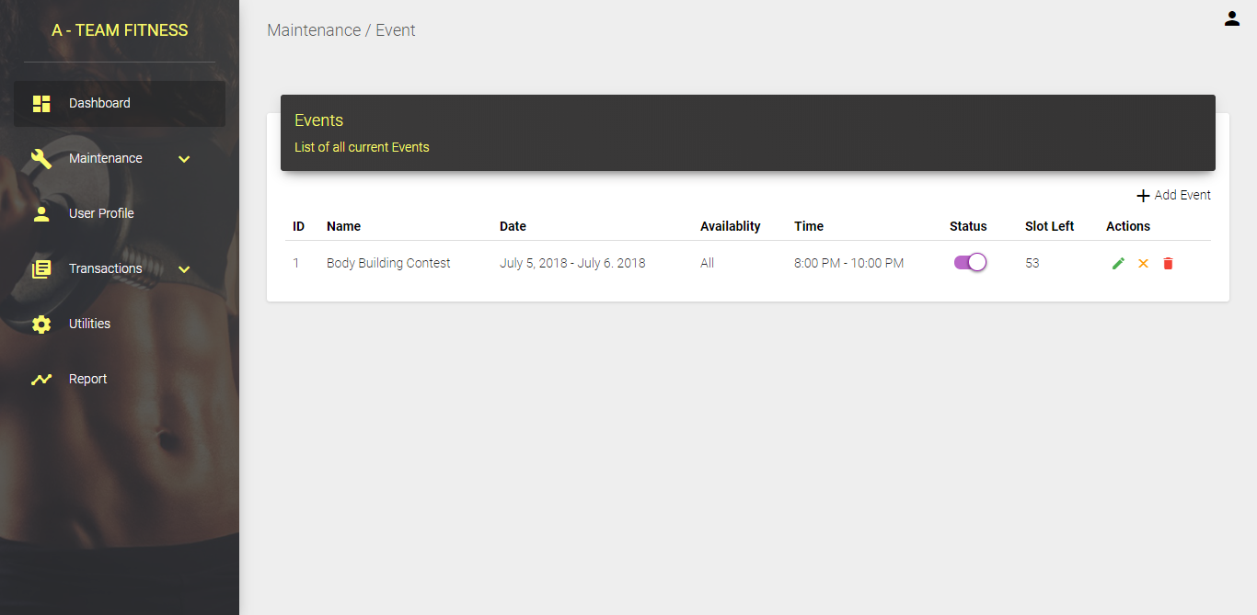

Admin View: Pending Requests

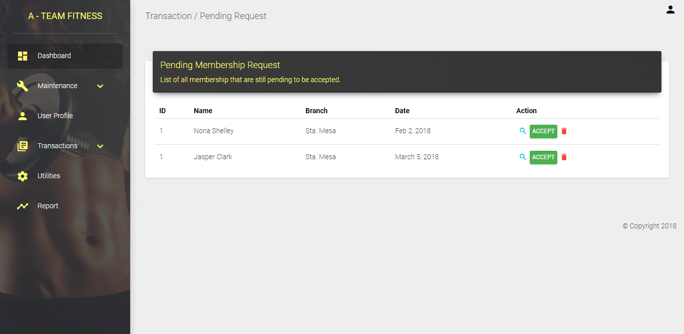

Admin View: Official Receipt

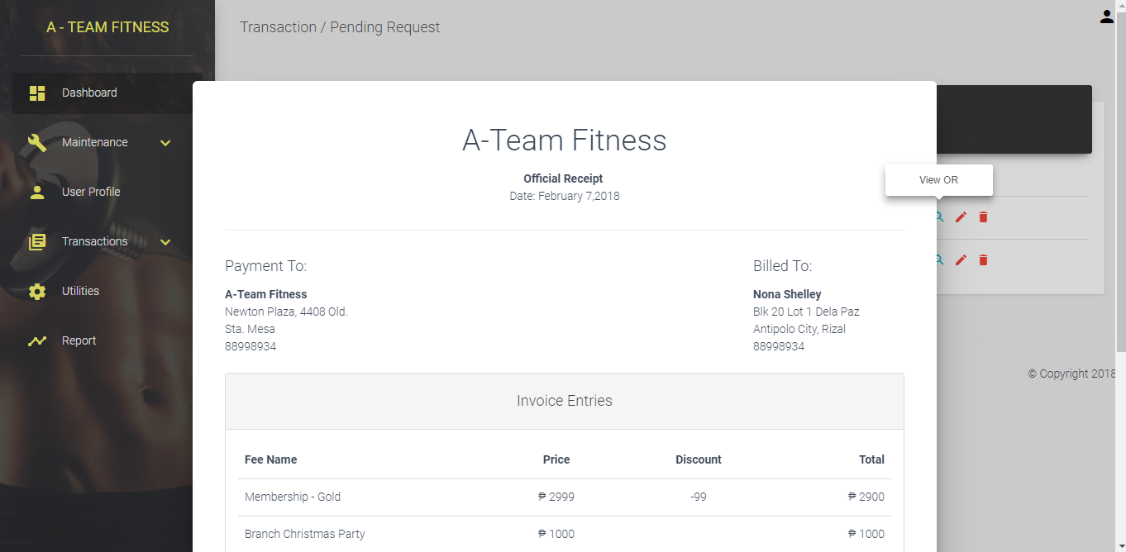

Admin View: General Settings

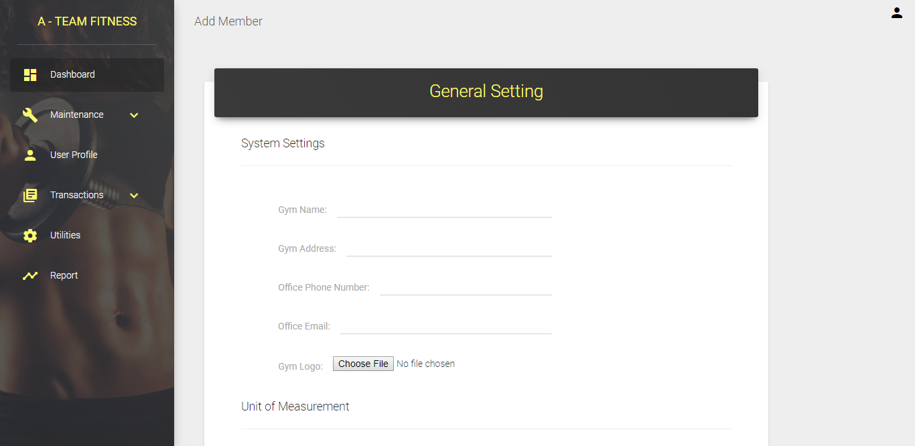

Admin View: Admin Settings

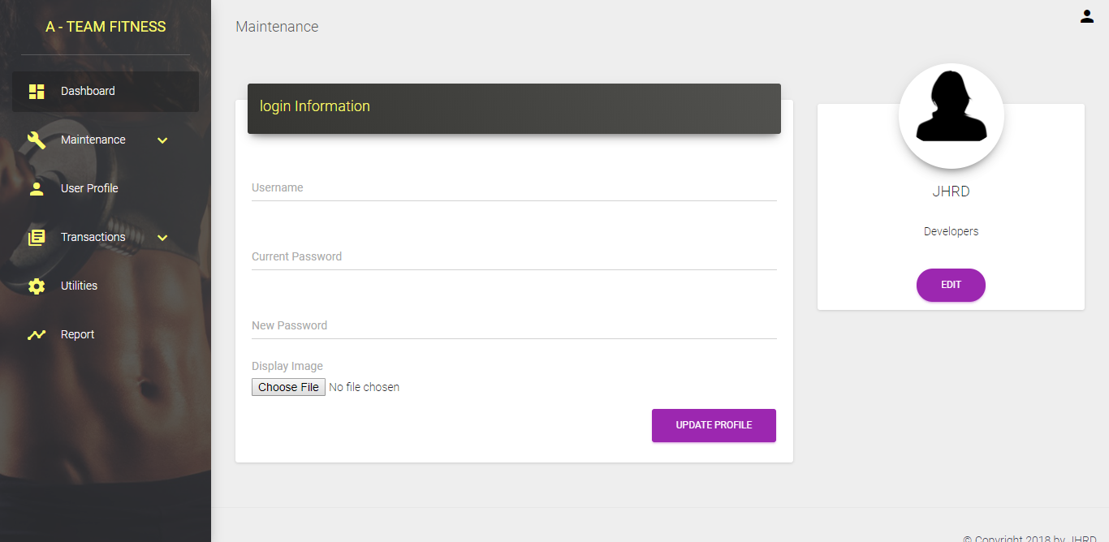

Admin View: Payment and Invoices

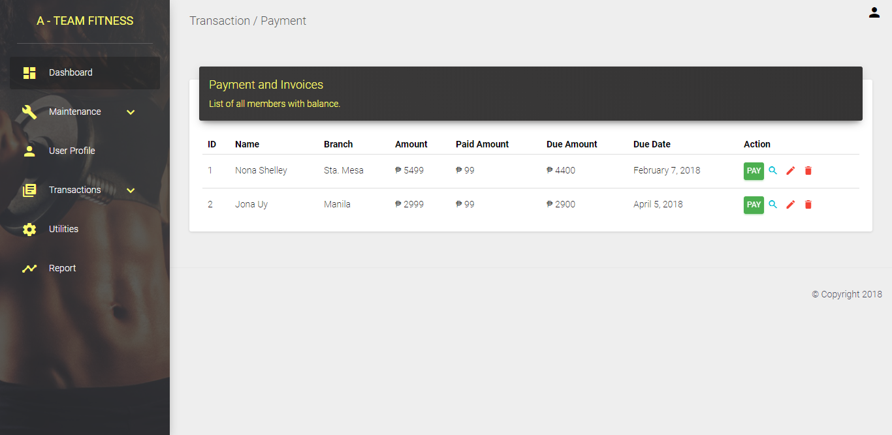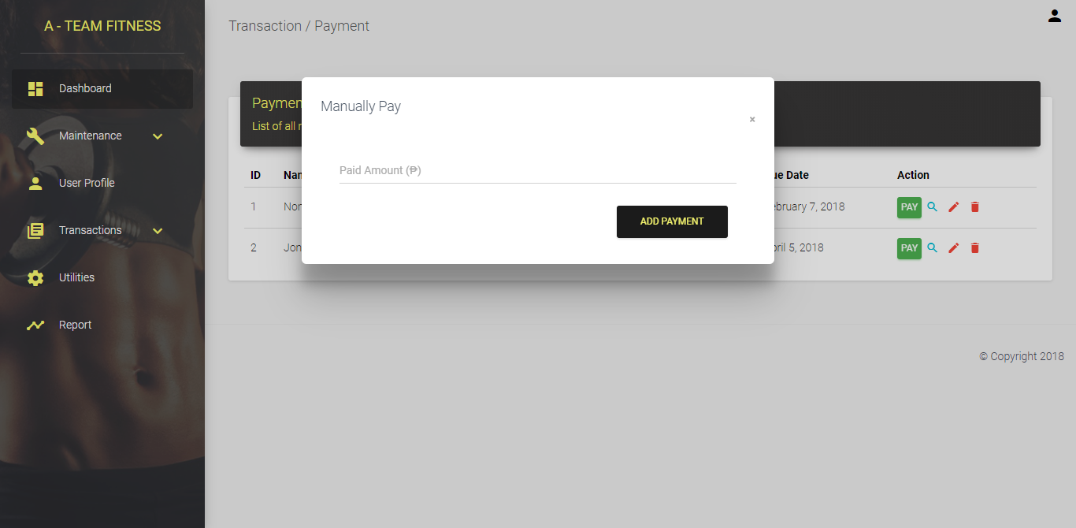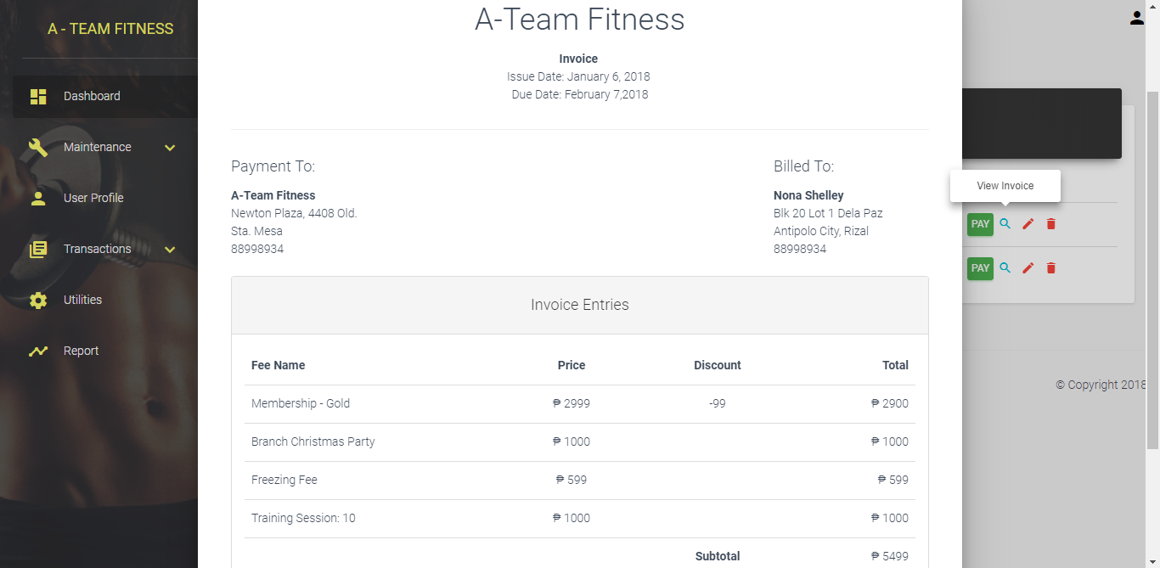

Admin View: Reports

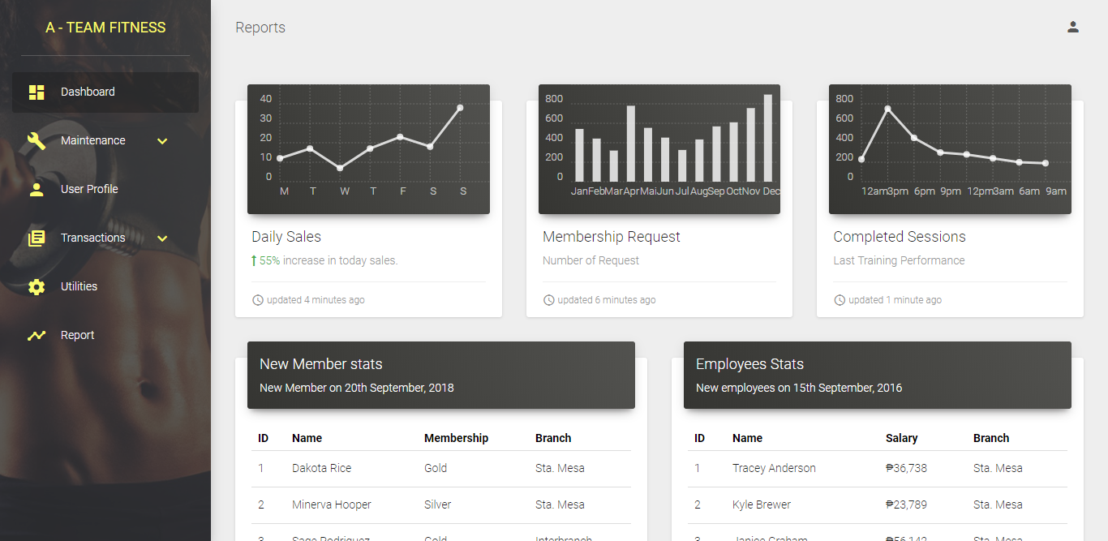

Member View: Schedule

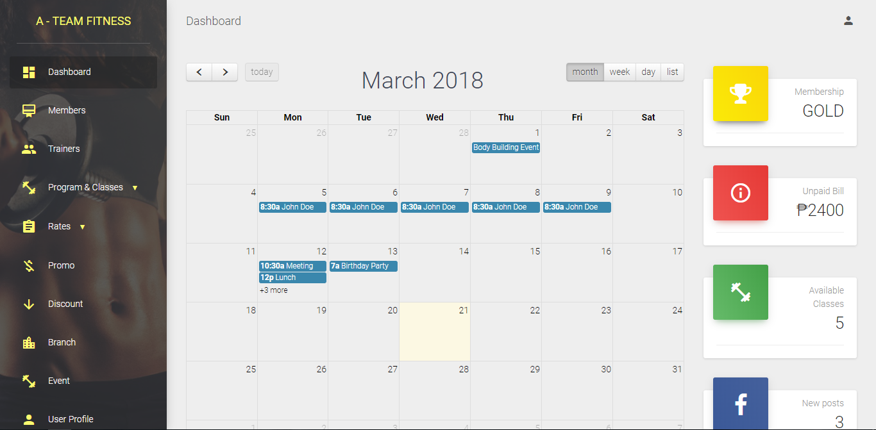

Member View: Trainer Application

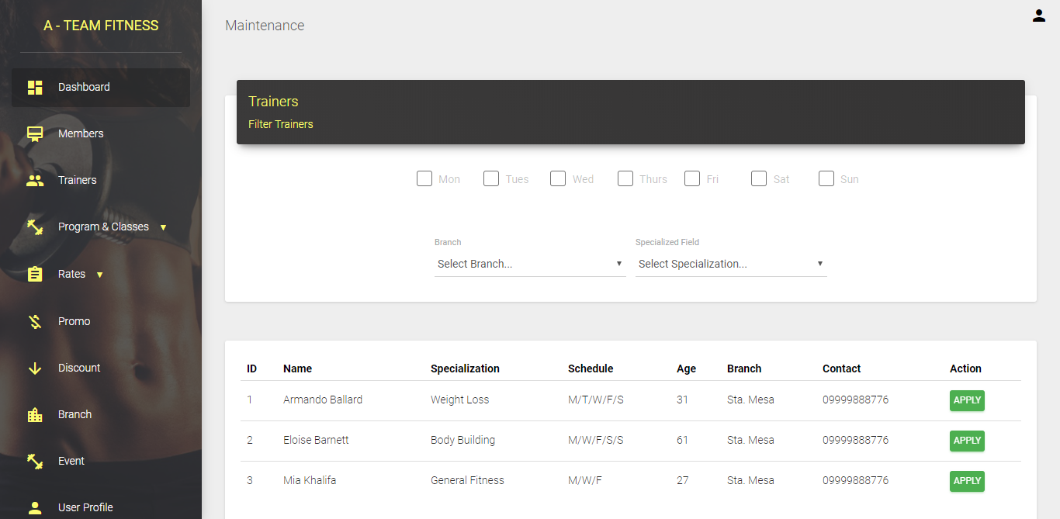

Member View: Personal Trainer Tab

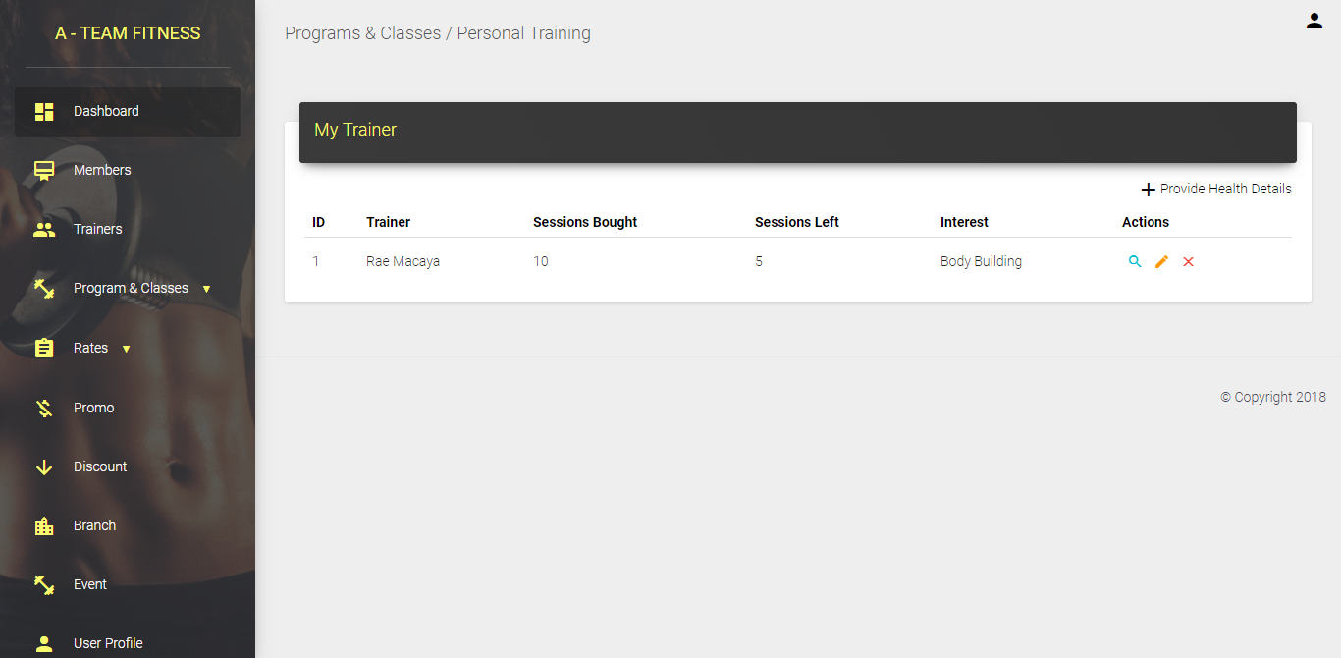

Member View: Health Form

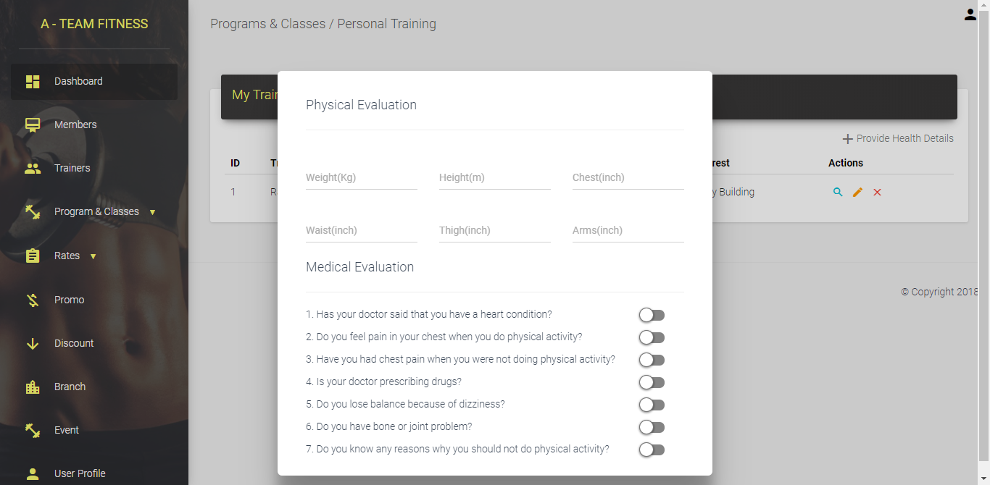

Member View: Schedule

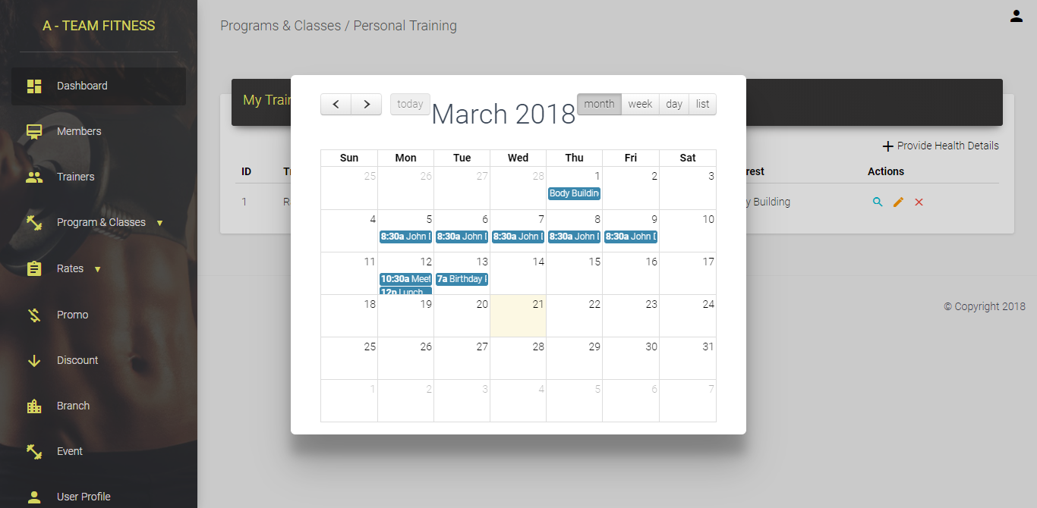

Member View (Modal): Rescheduling

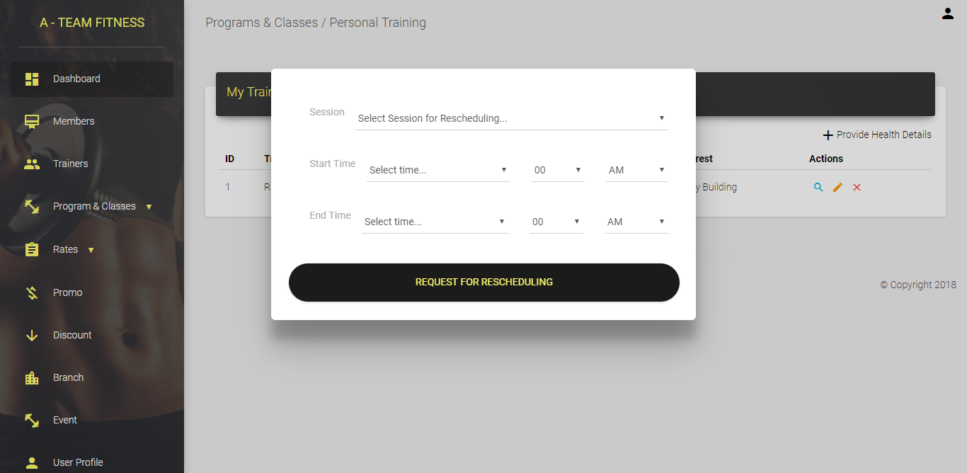

Member View: Group Classes

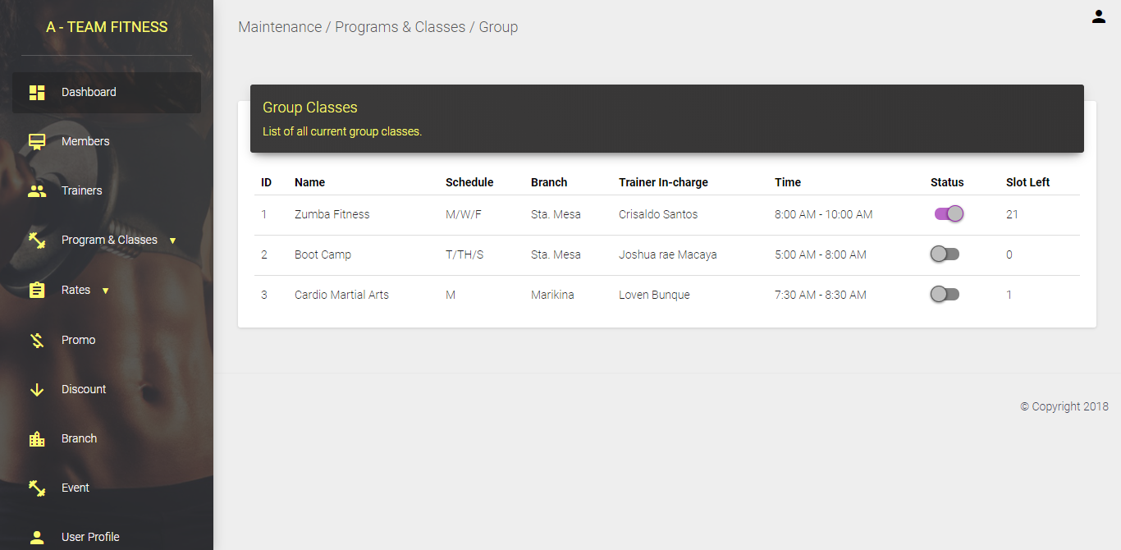

Member View: Events

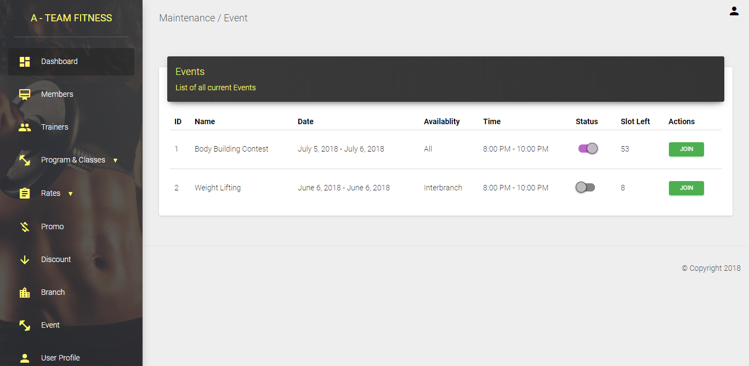

Member View: User Profile

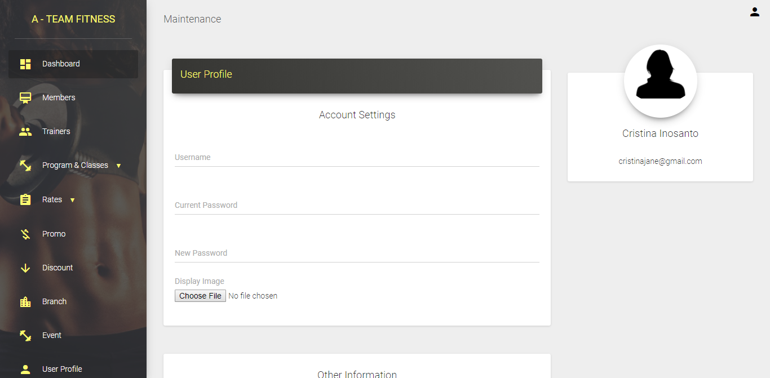

Member View: Payment and Invoices

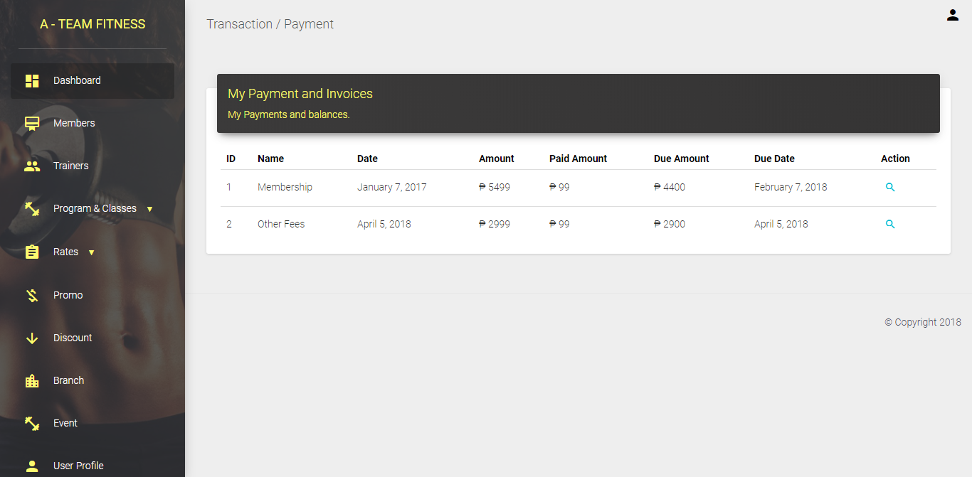

Member View: Reports

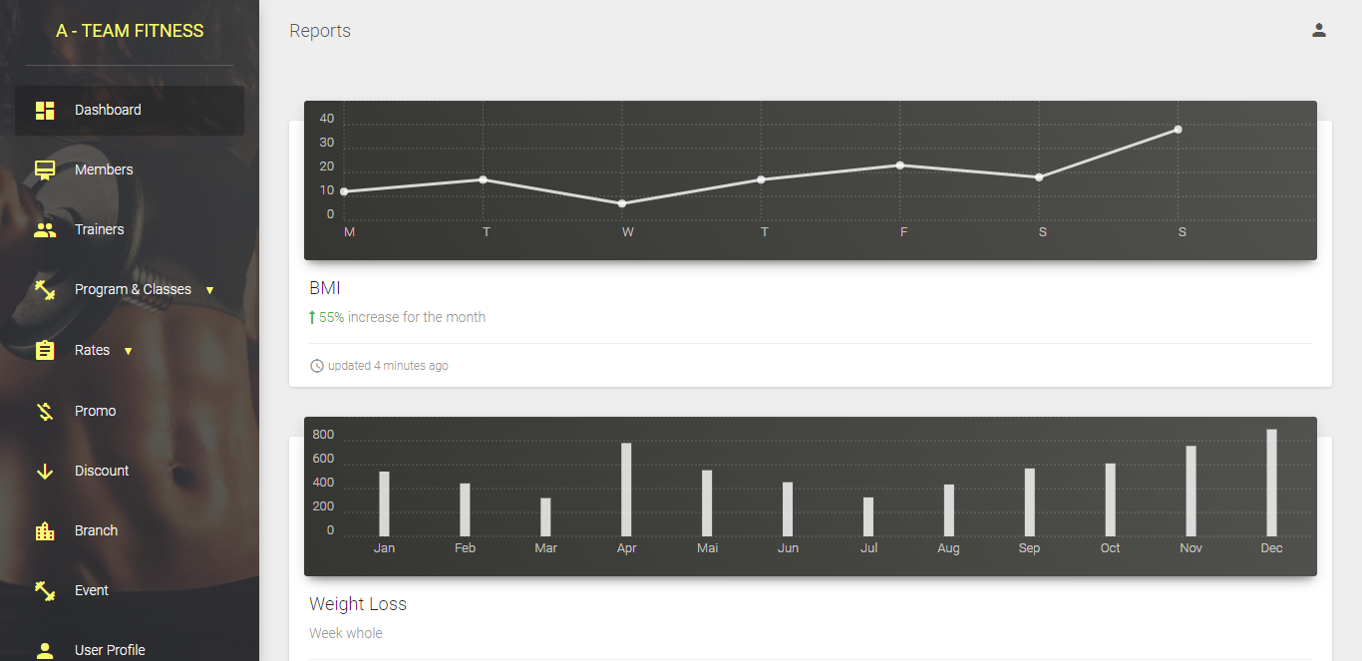

Trainer View: Dashboard

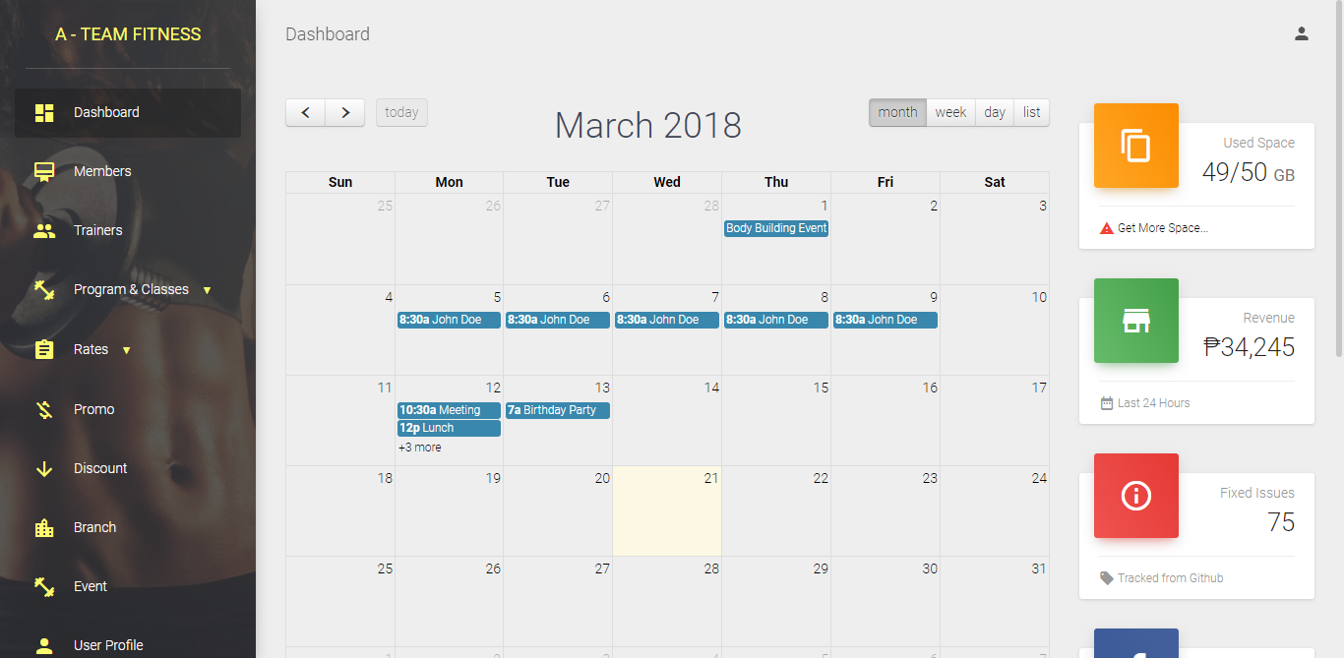

Trainer View: Overview

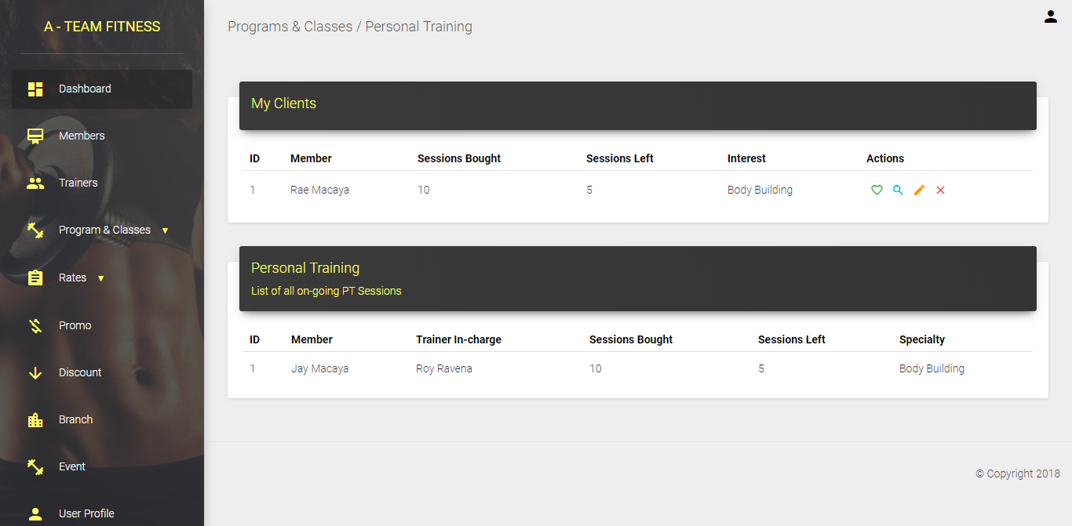

Trainer View (Modal): Finished Sessions

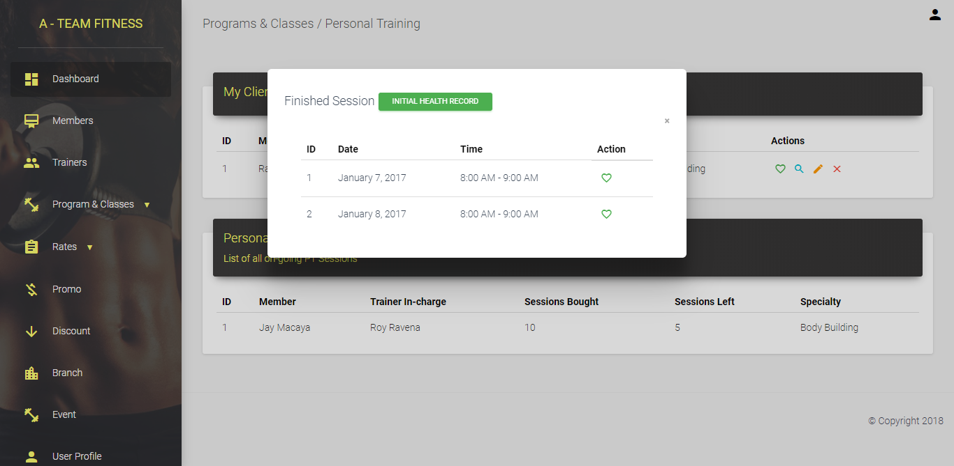

Trainer View: Health Forms

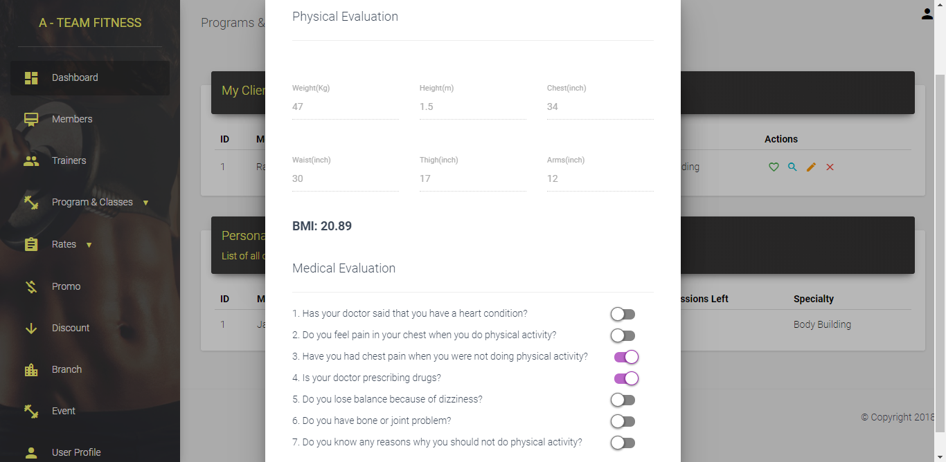

Trainer View: Schedule

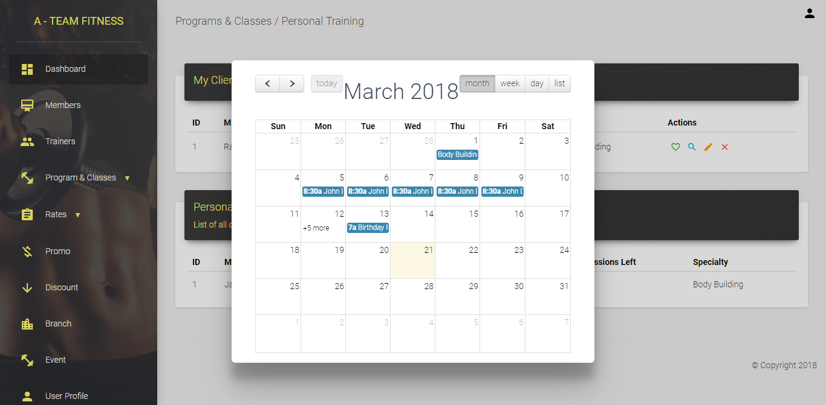

Trainer View (Modal): Set Schedule

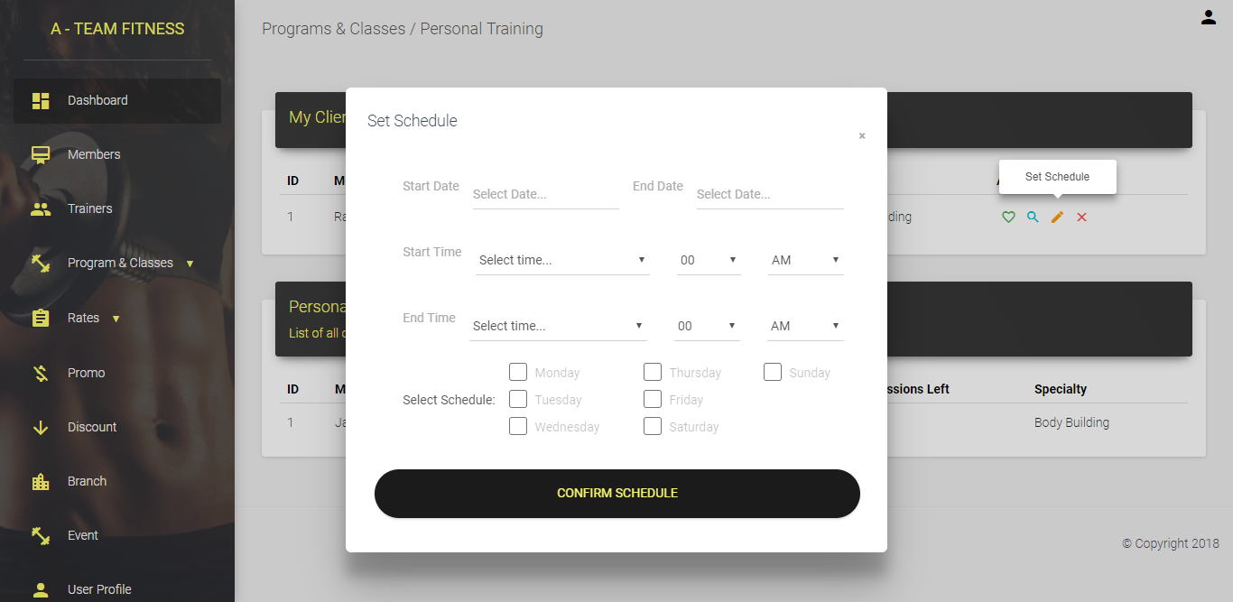

Trainer View: Group Classes

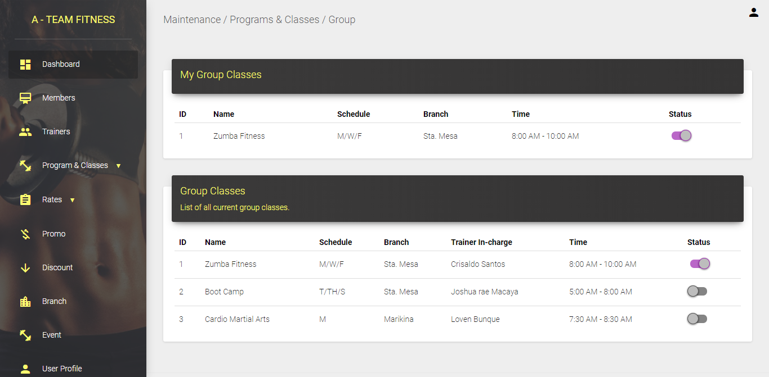

Trainer View: Events

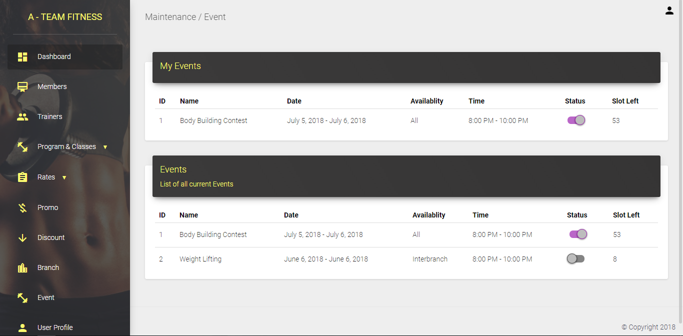

Trainer View: User Profile

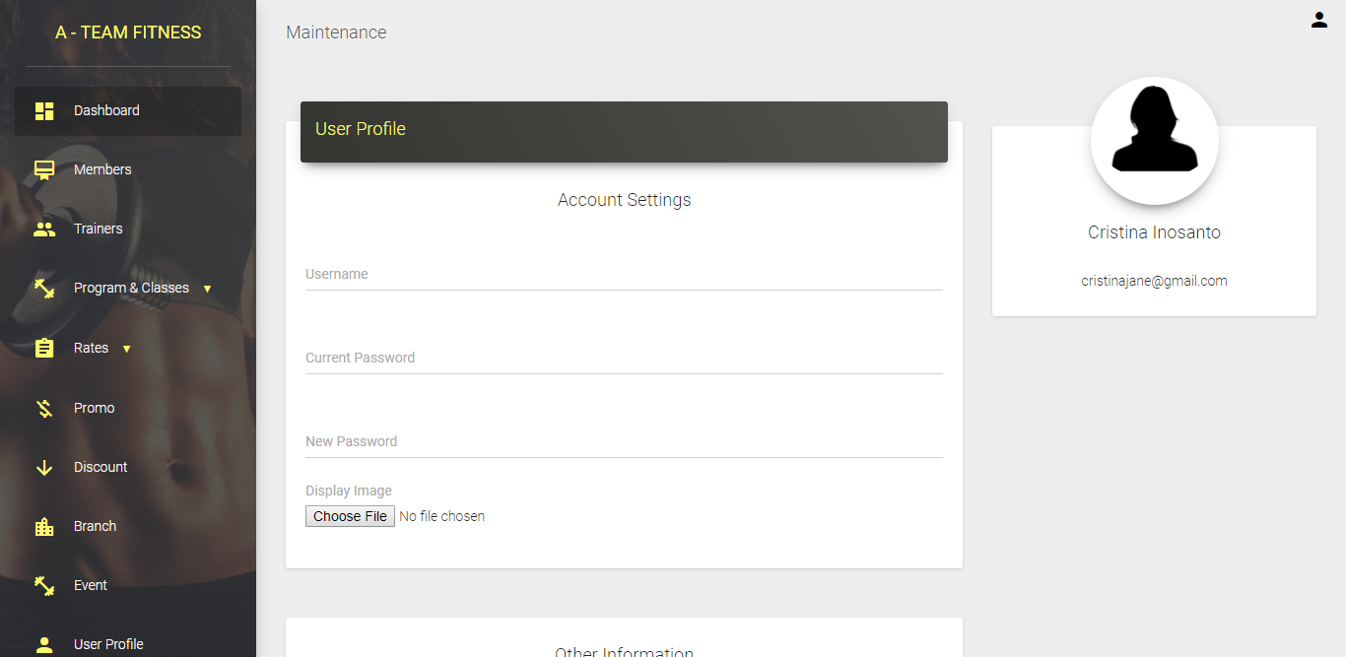

Trainer View: Pending Requests

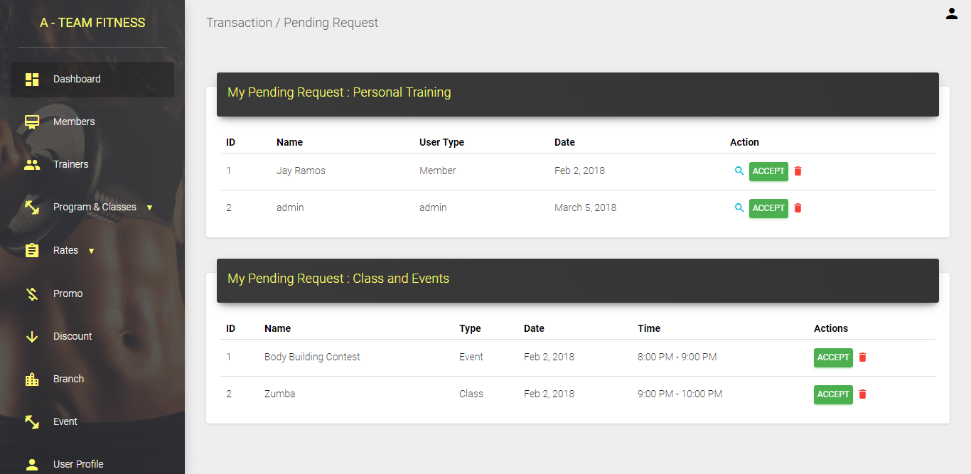

Trainer View (Modal): Requests

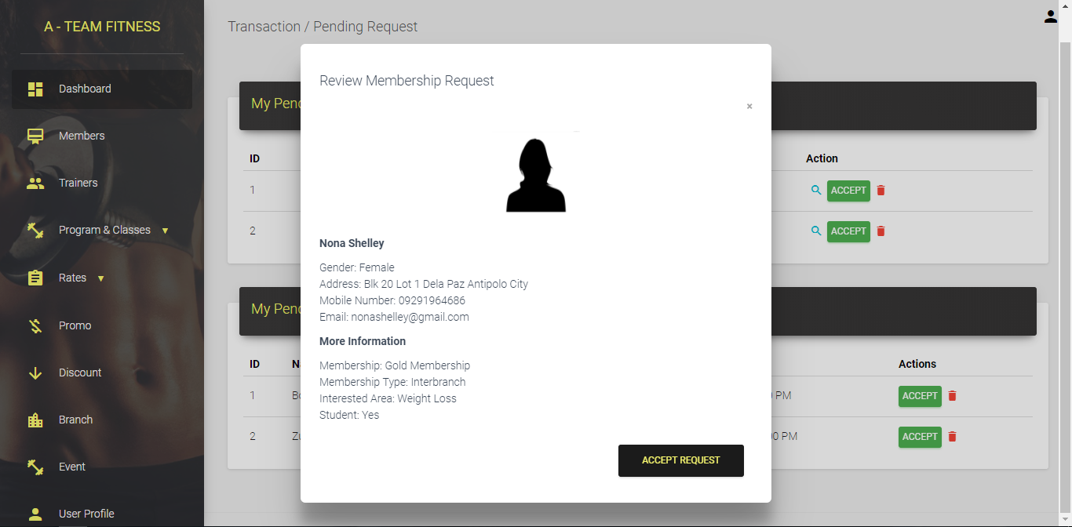

Trainer View: Reports

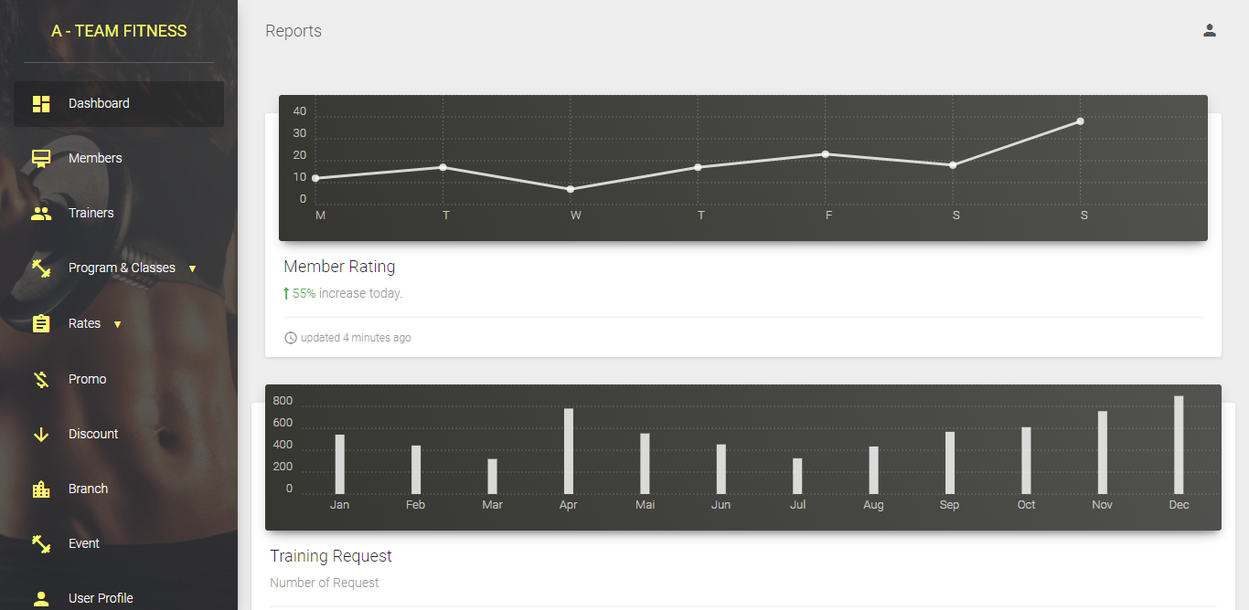

* + 1. Entity Relationship Diagram
    2. Data Dictionary

|  |  |  |  |  |  |  |  |  |
| --- | --- | --- | --- | --- | --- | --- | --- | --- |
| Table Name: tblBranch  Table Description: A table that contains Branch names and address of the fitness gym.  Related Table: None | | | | | | | | |
| Key | Field Name | Data Type | Length | Optional | Default Value | Field Validation | Description | Sample Data |
| PK | intBranchID | INT | 11 | N | None | Auto Increment | Unique identifier for each branch. | 01 |
|  | strBranchName | VARCHAR | 30 | N | None | None | Name of the Branch | A-Team Fitness, Sta. Mesa |
|  | strBranchAddress | VARCHAR | 200 | N | None | None | Address of the Branch | 12 Old Sta. Mesa, Manila |
| FK | intStaffID | INT | 11 | N | None | None | ID of the staff member working in the branch | 12 |

|  |  |  |  |  |  |  |  |  |
| --- | --- | --- | --- | --- | --- | --- | --- | --- |
| Table Name: tblUser  Table Description: A table consists all the details of the users.  Related Table: None | | | | | | | | |
| Key | Field Name | Data Type | Length | Optional | Default Value | Field Validation | Description | Sample Data |
| PK | intUserID | INT | 11 | N | None | Auto Increment | Unique identifier of user. | 01 |
|  | strUserName | VARCHAR | 80 | N | None | None | The full name of the user. | John Homer Cadena |
|  | strUserEmail | VARCHAR | 45 | N | None | None | The email of the user used to sign up and log in. | [homercadena@gmail.com](mailto:homercadena@gmail.com) |
|  | strPassword | VARCHAR | 30 | N | None | None | The password of the user’s account | homiecadie123 |
|  | intUserType | INT | 1 | N | None | None | Determines what kind the user is. | 1 |
|  | strUserDP | LONGTEXT | N/A | Y | None | None | Provides the link to the folder containing the user’s profile picture. | C:\Users\*****\Documents\USerDP |
|  | boolExclusive | TINYINT | 1 | N | None | None | Determines whether the user has an exclusive or inter-branch membership | 1 |
| FK | intUserBranchID | INT | 11 | Y | None | None | ID for the branch the user is enrolled in. | 08 |
|  | strContact | VARCHAR | 13 | N | None | None | Contact number of the user. | +639083586707 |
|  | strUserAddress | LONGTEXT | N/A | N | None | None | Home address of the user. | 68E F.C. Cruz St. Pateros |
|  | charGender | VARCHAR | 1 | N | None | None | Determines the gender of the user. | M |
|  | datBday | DATE | N/A | N | None | None | The birth date of the user. | 06/05/1999 |
|  | strPaymentCode | VARCHAR | 7 | Y | None | None | Payment code needed for the user to sign up. | u76A26G |
| FK | intEnrollID | INT | 11 | Y | None | None | ID for what class the user is enrolled in | 02 |
| FK | intRateID | INT | 11 | N | None | None | ID for how much discount and amount the user has to pay. | 06 |

|  |  |  |  |  |  |  |  |  |
| --- | --- | --- | --- | --- | --- | --- | --- | --- |
| Table Name: tblClass  Table Description: A table that consists of the classes available for the user to enroll in.  Related Table: tblUser | | | | | | | | |
| Key | Field Name | Data Type | Length | Optional | Default Value | Field Validation | Description | Sample Data |
| PK | intClassID | INT | 11 | N | None | Auto Increment | Unique identifier for each class. | 01 |
|  | strClassName | VARCHAR | 30 | N | None | None | The name of the class. | Indoor Cycling |
|  | txtClassDesc | LONGTEXT | N/A | N | None | None | Description of the class. | A vigorous and thrilling indoor... |
|  | intStatus | INT | 1 | N | None | None | Determines whether the class is available or not | 1 |

|  |  |  |  |  |  |  |  |  |
| --- | --- | --- | --- | --- | --- | --- | --- | --- |
| Table Name: tblEnroll  Table Description: A table contains the records of members that are enrolled in a certain class.  Related Table: tblUser, tblTrainer | | | | | | | | |
| Key | Field Name | Data Type | Length | Optional | Default Value | Field Validation | Description | Sample Data |
| PK | intEnrollID | INT | 11 | N | None | Auto Increment | Unique identifier for each record of each enrollees. | 01 |
| FK | intUserID | INT | 11 | N | None | None | ID of the user enrolled in a class. | 03 |
| FK | intTrainerID | INT | 11 | N | None | None | ID of the trainer managing a class. | 04 |
| FK | intClassID | INT | 11 | N | None | None | ID of the class the user in enrolled in. | 05 |
|  | datSchedule | DATE | N/A | N | None | None | Schedule of the classes. | 04/12/2018 |
|  | boolStatus | TINYINT | 1 | N | None | None | Determines status of each users involved in a class. | 0 |

|  |  |  |  |  |  |  |  |  |
| --- | --- | --- | --- | --- | --- | --- | --- | --- |
| Table Name: tblFacAvail  Table Description: A table that consists the facilities available for each branch,  Related Table: tblBranch, tblFacilities | | | | | | | | |
| Key | Field Name | Data Type | Length | Optional | Default Value | Field Validation | Description | Sample Data |
| PK | intFAID | INT | 11 | N | None | Auto Increment | Unique identifier of the table. | 01 |
| FK | intBranchID | INT | 11 | N | None | None | ID of the branch the facility belongs to. | 11 |
| FK | intFacilityID | INT | 11 | N | None | None | ID of the facility available for a branch. | 05 |

|  |  |  |  |  |  |  |  |  |
| --- | --- | --- | --- | --- | --- | --- | --- | --- |
| Table Name: tblFacilities  Table Description: A table contains the records of each facility available for a branch.  Related Table: tblFacAvail | | | | | | | | |
| Key | Field Name | Data Type | Length | Optional | Default Value | Field Validation | Description | Sample Data |
| PK | intFacilityID | INT | 11 | N | None | Auto Increment | Unique identifier for the facility. | 01 |
|  | strFacilityName | VARCHAR | 45 | N | None | None | Name of the facility. | Sauna |
|  | fltFee | FLOAT | N/A | N | None | None | Fee needed to pay in order to use a facility. | 5.00 |
|  | intDuration | INT | 11 | N | None | None | The duration a user can use a facility for a certain price. | 1 |
|  | strUOM | VARCHAR | 15 | N | None | None | The unit of measure used to measure the time. | hour |

|  |  |  |  |  |  |  |  |  |
| --- | --- | --- | --- | --- | --- | --- | --- | --- |
| Table Name: tblGeneral  Table Description: A table that contains general fee of the gym including miscellaneous fees.  Related Table: tblUserGen | | | | | | | | |
| Key | Field Name | Data Type | Length | Optional | Default Value | Field Validation | Description | Sample Data |
| PK | intGeneralID | INT | 11 | N | None | Auto Increment | Unique identifier for the general fee. | 01 |
|  | strGenName | VARCHAR | 50 | N | None | None | Name of the general fee. | Training Sessions |
|  | intGenPeriod | INT | 11 | N | None | None | The duration of the general payment. | 2 |
|  | fltGenFee | FLOAT | N/A | N | None | None | The cost of the general fee. | 50.00 |
|  | strUOM | VARCHAR | 20 | N | None | None | The unit of measurement used in general fee. | sessions |

|  |  |  |  |  |  |  |  |  |
| --- | --- | --- | --- | --- | --- | --- | --- | --- |
| Table Name: tblMembership  Table Description: A table that consists of the type of membership a user can avail.  Related Table: None | | | | | | | | |
| Key | Field Name | Data Type | Length | Optional | Default Value | Field Validation | Description | Sample Data |
| PK | intMemberShipID | INT | 11 | N | None | Auto Increment | Unique identifier for the membership type. | 01 |
|  | strMemName | VARCHAR | 20 | N | None | None | Name of the membership type a user can avail. | Exclusive |
|  | txtMemDesc | LONGTEXT | N/A | N | None | None | Description of the membership type. | Exclusive to only one of our branches |
|  | boolStatus | TINYINT | 1 | N | None | None | Status of the membership type (if a user can avail the membership or not) | 1 |

|  |  |  |  |  |  |  |  |  |
| --- | --- | --- | --- | --- | --- | --- | --- | --- |
| Table Name: tblNotifications  Table Description: A table that consists of the notifications for a user.  Related Table: tblUser | | | | | | | | |
| Key | Field Name | Data Type | Length | Optional | Default Value | Field Validation | Description | Sample Data |
| PK | intNotifID | INT | 11 | N | None | Auto Increment | Unique identifier for each notification. | 01 |
|  | datNotifTime | DATETIME | N/A | N | None | None | Determines the date and time a notification was sent to the user. | 1900-01-01 00:00:00 |
|  | txtNotifDesc | LONGTEXT | N/A | N | None | None | Description of the notification sent to the user. | A trainer has accepted your request. |
| FK | intNUserID | INT | 11 | N | None | None | The ID of the user the notification belongs to. | 02 |

|  |  |  |  |  |  |  |  |  |
| --- | --- | --- | --- | --- | --- | --- | --- | --- |
| Table Name: tblProgram  Table Description: A table that consists of the programs in a class.  Related Table: tblClass | | | | | | | | |
| Key | Field Name | Data Type | Length | Optional | Default Value | Field Validation | Description | Sample Data |
| PK | intProgramId | INT | 11 | N | None | Auto Increment | Unique identifier for the program. | 01 |
|  | strProgramName | VARCHAR | 30 | N | None | None | Name of the program. | Boxing. |
|  | txtProgDesc | LONGTEXT | N/A | N | None | None | Description of the program | The sport or practice of fighting with the fists... |
| FK | intProgClassID | INT | 11 | N | None | None | ID of the class the program belongs to. | 01 |

|  |  |  |  |  |  |  |  |  |
| --- | --- | --- | --- | --- | --- | --- | --- | --- |
| Table Name: tblPromo  Table Description: A table that consists of the available promos of the gym  Related Table: tblBranch | | | | | | | | |
| Key | Field Name | Data Type | Length | Optional | Default Value | Field Validation | Description | Sample Data |
| PK | intPromoID | INT | 11 | N | None | Auto Increment | Unique identifier of the promo. | 01 |
|  | strPromoName | VARCHAR | 50 | N | None | None | Name of the promo available | New Year Promo |
|  | datStart | DATE | N/A | N | None | None | Starting date of the promo | 01/01/2019 |
|  | datEnd | DATE | N/A | N | None | None | End date of the promo. | 02/01/2019 |
|  | strStatus | VARCHAR | 9 | N | None | None | Determines whether the promo is active or inactive | Active |
|  | intStatusBack | INT | 1 | N | None | None | Determines if the promo will be needed in the future. | 1 |
|  | intPromoBranchID | INT | 11 | N | None | None | ID of the branch the promo is active. | 02 |

|  |  |  |  |  |  |  |  |  |
| --- | --- | --- | --- | --- | --- | --- | --- | --- |
| Table Name: tblRates  Table Description: A table that consists of the different rates in price for each member  Related Table: tblMembership, tblType | | | | | | | | |
| Key | Field Name | Data Type | Length | Optional | Default Value | Field Validation | Description | Sample Data |
| PK | intRateID | INT | 11 | N | None | Auto Increment | Unique identifier of the different rates | 01 |
|  | fltRatePrice | FLOAT | N/A | N | None | None | Determines how much the user needs to pay | 300.00 |
| FK | intMembershipID | INT | 11 | N | None | None | ID for the membership type needed to determine the fee. | 02 |
| FK | intTypeID | INT | 11 | N | None | None | ID for the level of membership the user availed. | 01 |
|  | intPeriod | INT | 11 | N | None | None | Determines how long in days the user is subscribed to the gym | 31 |

|  |  |  |  |  |  |  |  |  |
| --- | --- | --- | --- | --- | --- | --- | --- | --- |
| Table Name: tblSpecialization  Table Description: A table that consists of the different specializations a trainer can have.  Related Table: tblTrainer | | | | | | | | |
| Key | Field Name | Data Type | Length | Optional | Default Value | Field Validation | Description | Sample Data |
| PK | intSpecializationID | INT | 11 | N | None | Auto Increment | Unique identifier for each specialization. | 01 |
|  | strSpecialName | VARCHAR | 30 | N | None | None | Name of the specialization. | Aerobic Training |
|  | txtSpecialDesc | LONGTEXT | N/A | N | None | None | Contains the description of the specialization. | Aerobic training strengthens... |
|  | intStatus | INT | 1 | N | None | None | Determines the whether the specialization is needed or not. | 1 |

|  |  |  |  |  |  |  |  |  |
| --- | --- | --- | --- | --- | --- | --- | --- | --- |
| Table Name: tblTrainer  Table Description: A table that consists of the different trainers and their specializations.  Related Table: tblUser, tblSpecialization | | | | | | | | |
| Key | Field Name | Data Type | Length | Optional | Default Value | Field Validation | Description | Sample Data |
| PK | intTrainerID | INT | 11 | N | None | Auto Increment | Unique identifier for each trainer. | 01 |
|  | strTrainerName | VARCHAR | 80 | N | None | None | Consists of the name of the trainer. | Juan Buhat |
| FK | intSpecializationID | INT | 11 | N | None | None | ID of the specialization the trainer has. | 01 |

|  |  |  |  |  |  |  |  |  |
| --- | --- | --- | --- | --- | --- | --- | --- | --- |
| Table Name: tblType  Table Description: A table that consists of the different types of subscription the user can avail.  Related Table: tblRates | | | | | | | | |
| Key | Field Name | Data Type | Length | Optional | Default Value | Field Validation | Description | Sample Data |
| PK | intType | INT | 11 | N | None | Auto Increment | Unique identifier for the different types of subscriptions the user can avail. | 01 |
|  | strTypeName | VARCHAR | 10 | N | None | None | Name of the type of subscription the user can avail. | SILVER |
|  | txtTypeDesc | LONGTEXT | N/A | N | None | None | Description of the type. | Client Pays Semi-Annually |
|  | boolStatus | TINYINT | 1 | N | None | None | Determines whether that type can be availed or not. | 1 |

|  |  |  |  |  |  |  |  |  |
| --- | --- | --- | --- | --- | --- | --- | --- | --- |
| Table Name: tblUserGen  Table Description: A table that consists of the different general fees the user has to pay.  Related Table: tblUser, tblGeneral | | | | | | | | |
| Key | Field Name | Data Type | Length | Optional | Default Value | Field Validation | Description | Sample Data |
| PK | intUserGenID | INT | 11 | N | None | Auto Increment | Unique identifier of the table. | 01 |
| FK | intUGUserID | INT | 11 | N | None | None | ID of the user to which the fees are to. | 03 |
| FK | intUGGeneralID | INT | 11 | N | None | None | ID of the general fees the user has to pay. | 03 |

* 1. **DEVELOPMENT METHODOLOGY**
     1. **process model**

The proponents implemented the incremental process model.

Since that the project is divided into modules and sub-modules, the proponents sought the incremental process model is the way to describe their work. By implementing a step-by-step process and iterating the process flow repeatedly, the proponents can find errors or bugs to be fixed while on the way of the project’s development.

* + 1. **development tools**

The proponents used several tools to develop the system. The tools are divided into: software, language and dependencies, and browsers.

Software:

* Sublime Text 3
* Visual Studio Code
* Notepad++
* MySQL Workbench

Language and Dependencies:

* Node.js (Javascript)
* Pug (formerly Jade) – template engine
* MySQL Server 5.7

Browsers:

* Opera
* Firefox

**References**

[1] Ahmed, M., Nayeem, J. (2016).*Smart Gym Management System*. Department of Computer Science and Engineering, East West University, Dhaka, Bangladesh

[2] Peterson, Leif. (2009). K-nearest neighbor. *Scholarpedia, 4*(2):1883

[3] Neely, A., Gregory, M., & Platts, K. (1995). Performance measurement system design: A literature review and research agenda. *International Journal of Operations & Production Management, 15*(4), 80-116.

[4] Garrouste-Orgeas, M., Troché, G., Azoulay, E. et al. (2004). Body mass index: An additional prognostic factor in ICU patients. *Intensive Care Med 30*(3), 437-443.

[5] American Council on Exercise. (2013, Nov 4),*Know Your Numbers: Body Mass Index*, Retrieved from <https://www.acefitness.org/education-and-resources/lifestyle/blog/6780/know-your-numbers-body-mass-index>